**PART 1**

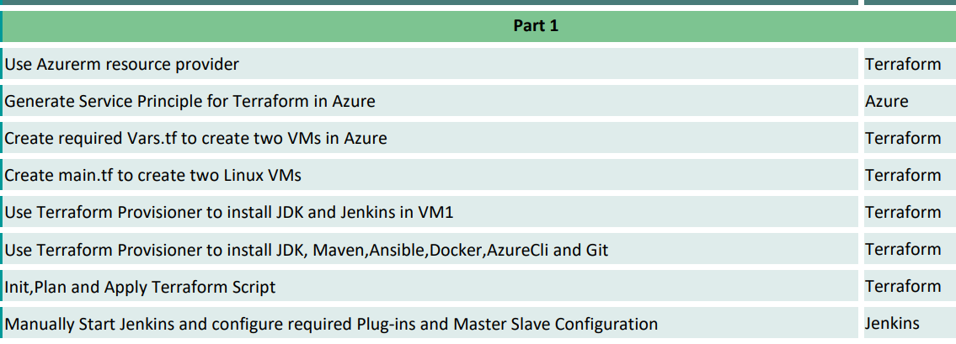

**Use Azurerm resource provider**

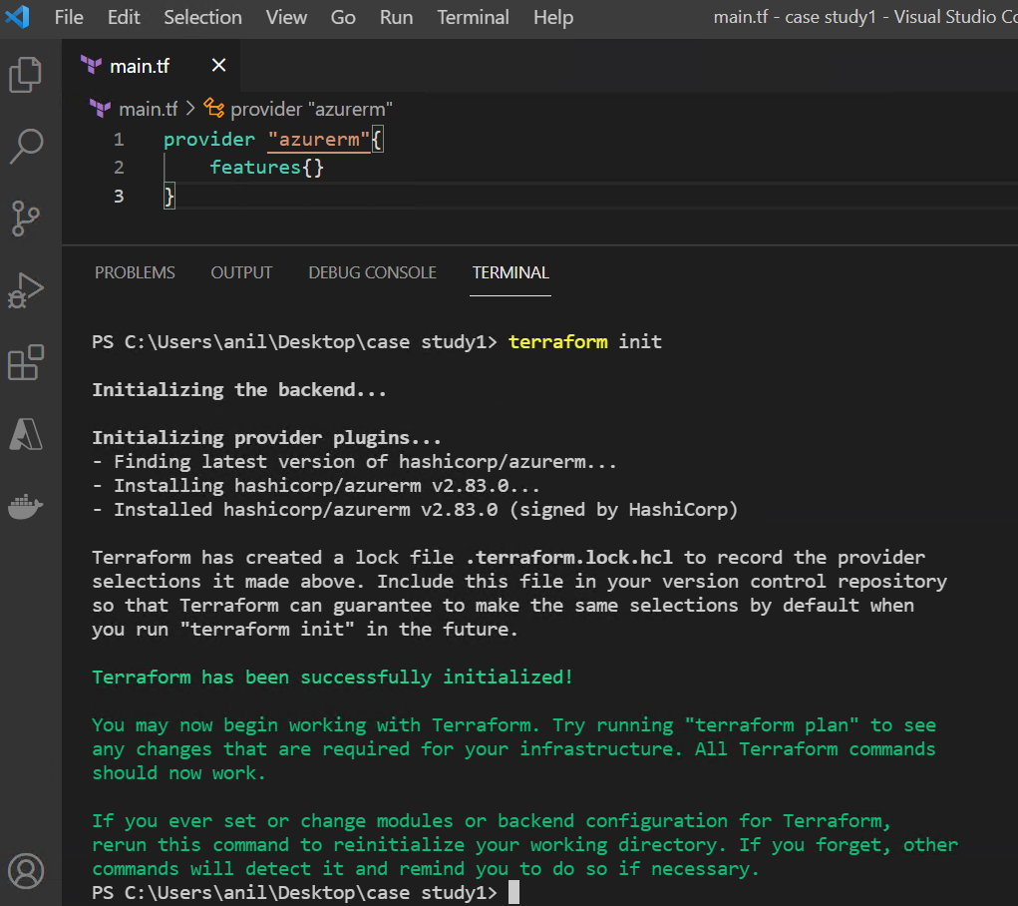

**Generate Service principle for terraform in azure**

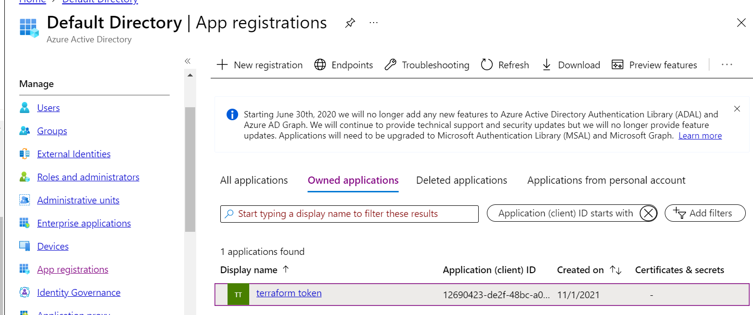

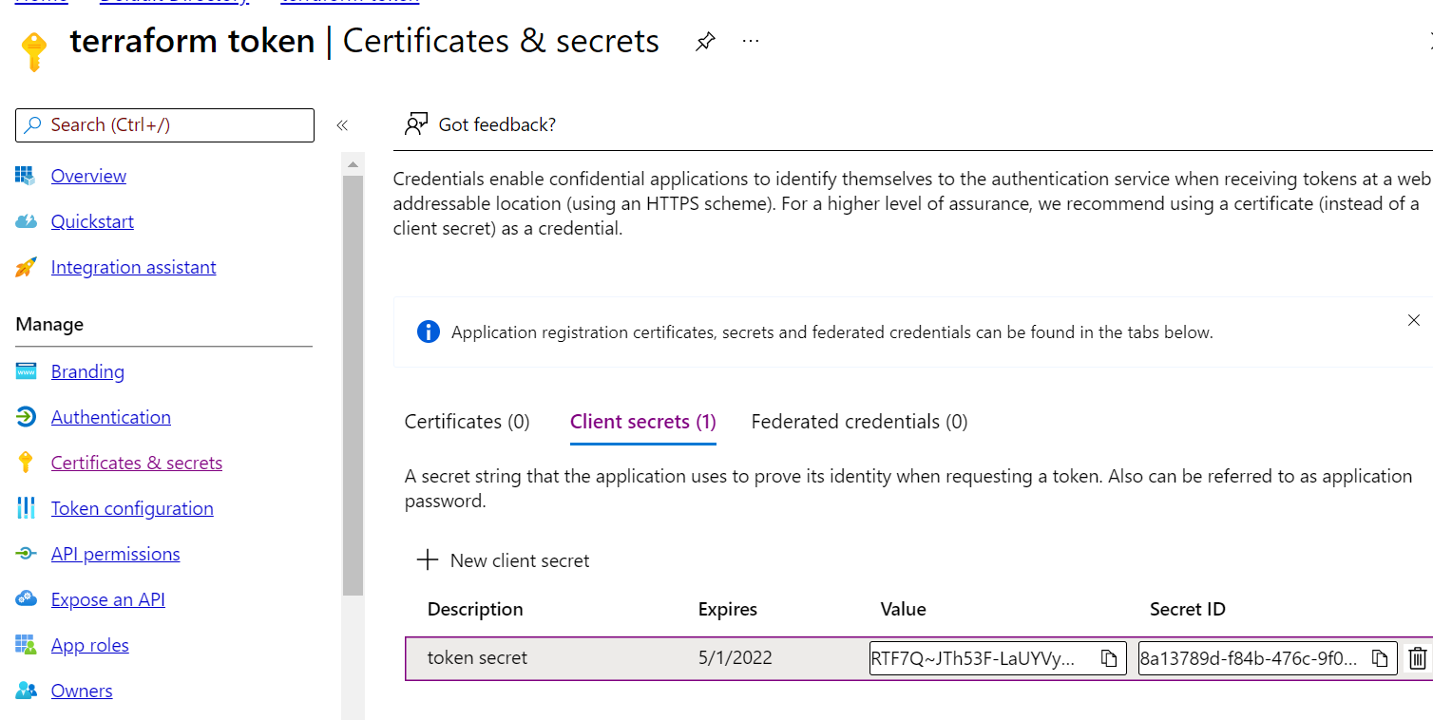

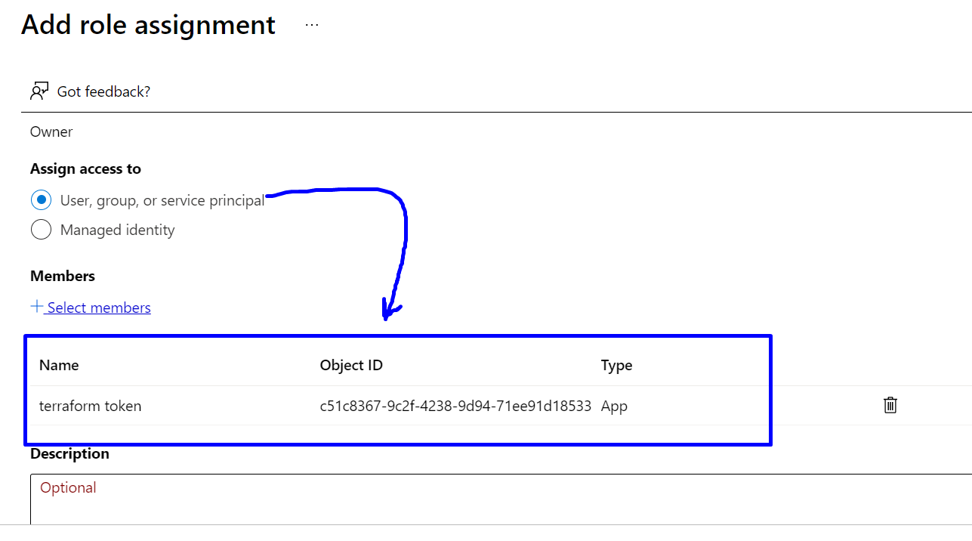

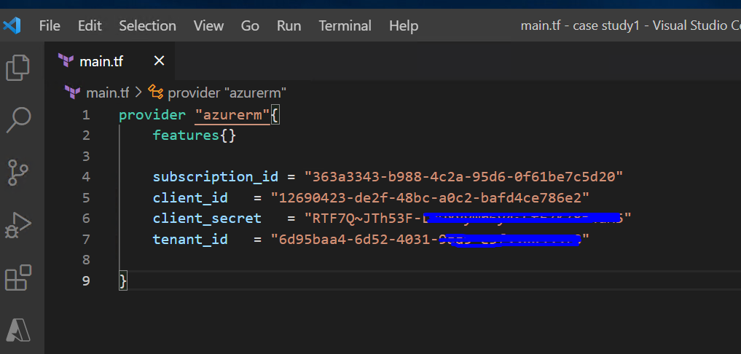

**Create required vars.tf to create two VMs in azure**

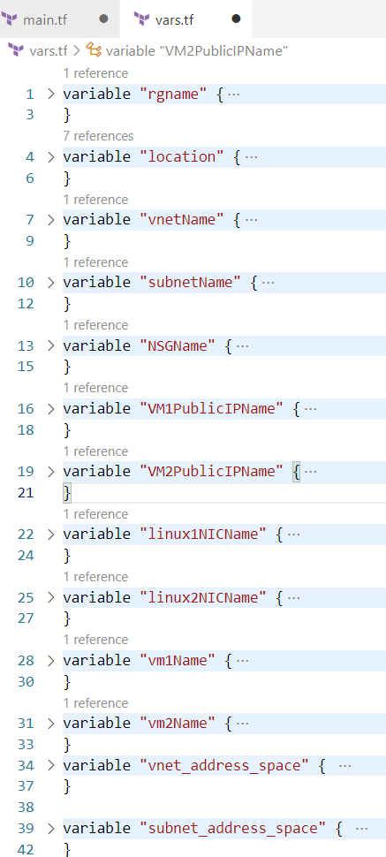

**Create main.tf to create two Linux VMs**

**Use Terraform Provisioner to install JDK and Jenkins in VM1**

**Use Terraform Provisioner to install JDK, Maven,Ansible,Docker,AzureCli and Git**

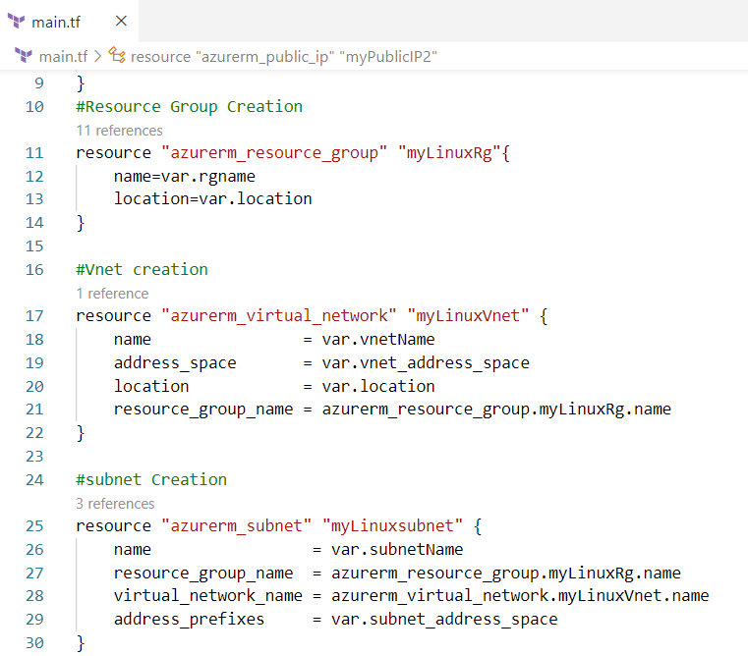

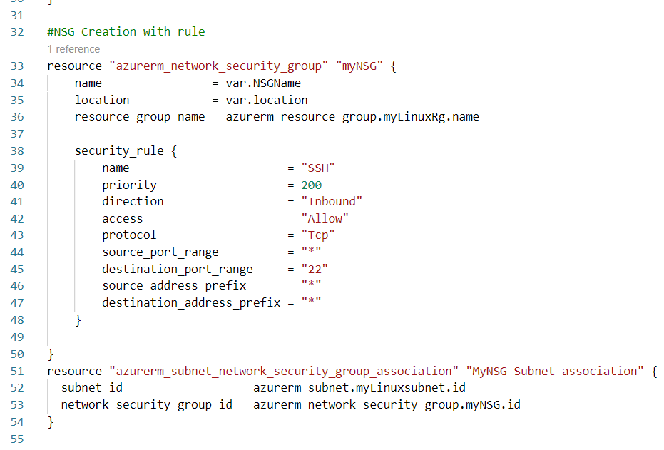

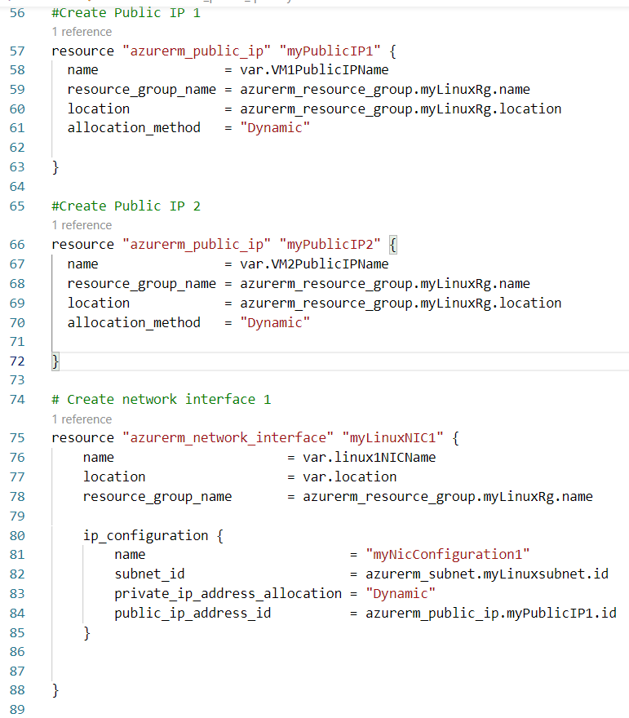

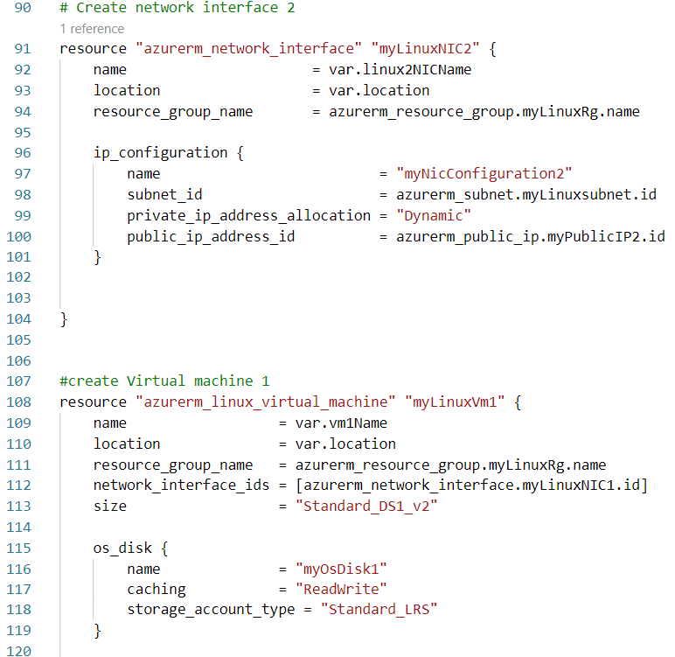

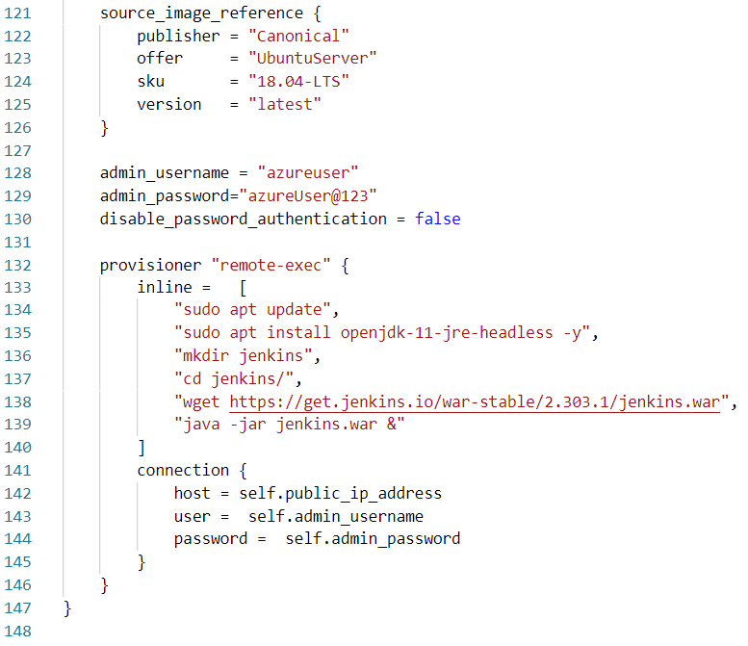

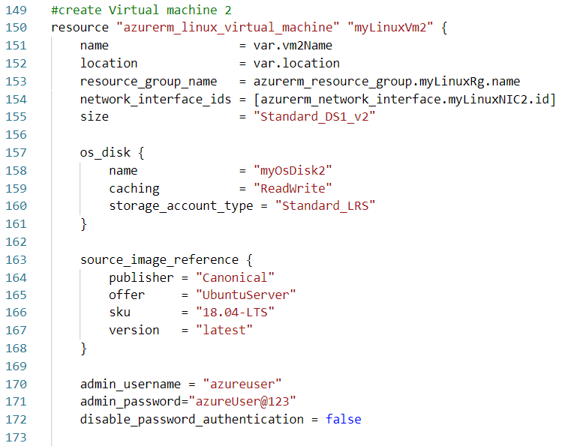

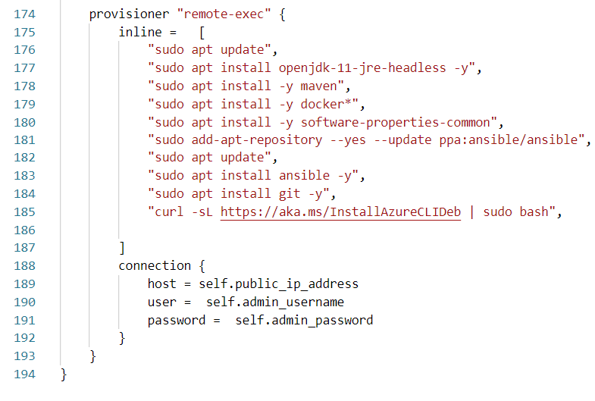

**Init,Plan and Apply Terraform Script**

Terraform init

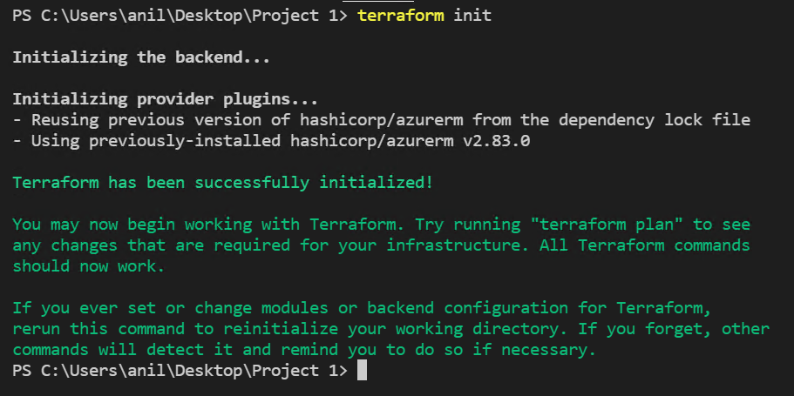

Terraform plan

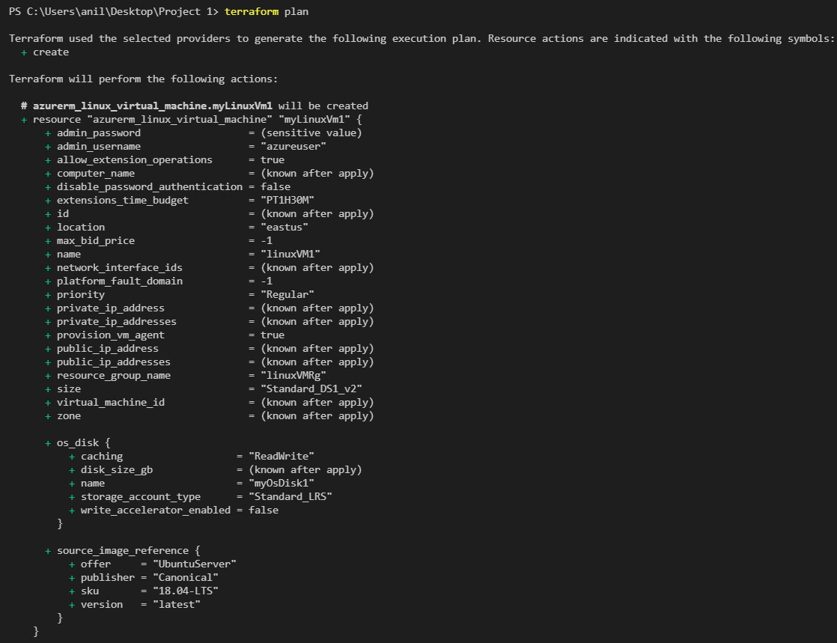

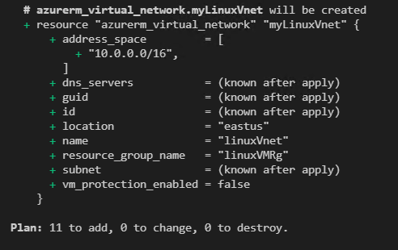

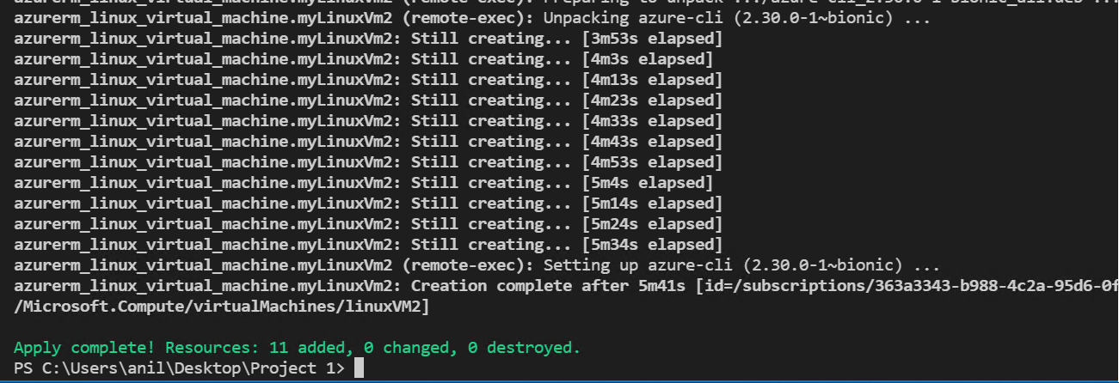

Terraform apply

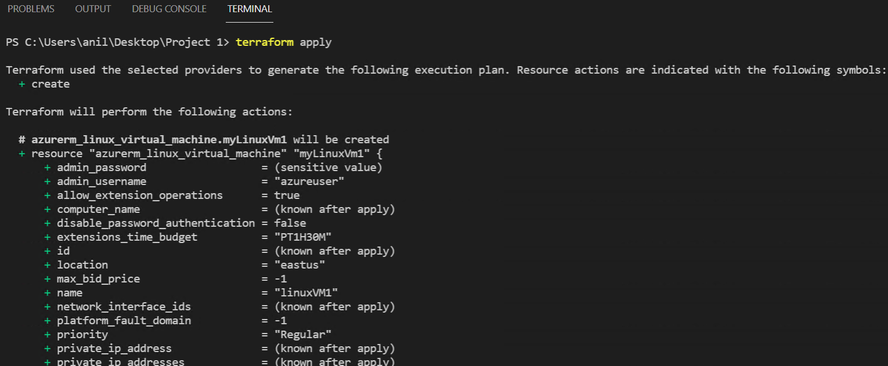

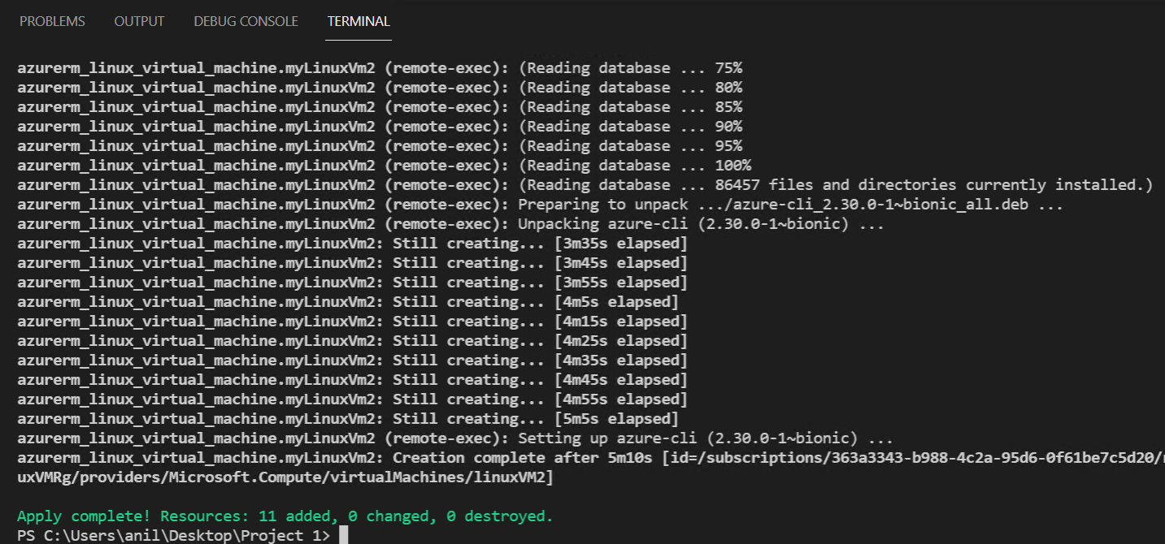

**Manually Start Jenkins and configure required Plug-ins and Master Slave Configuration**

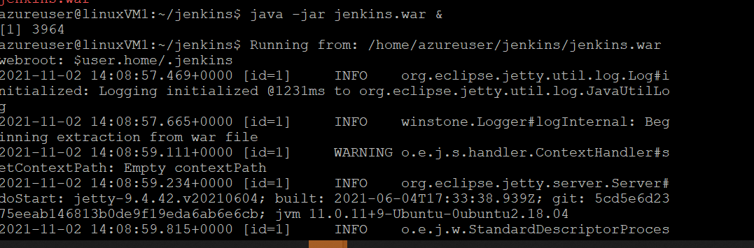

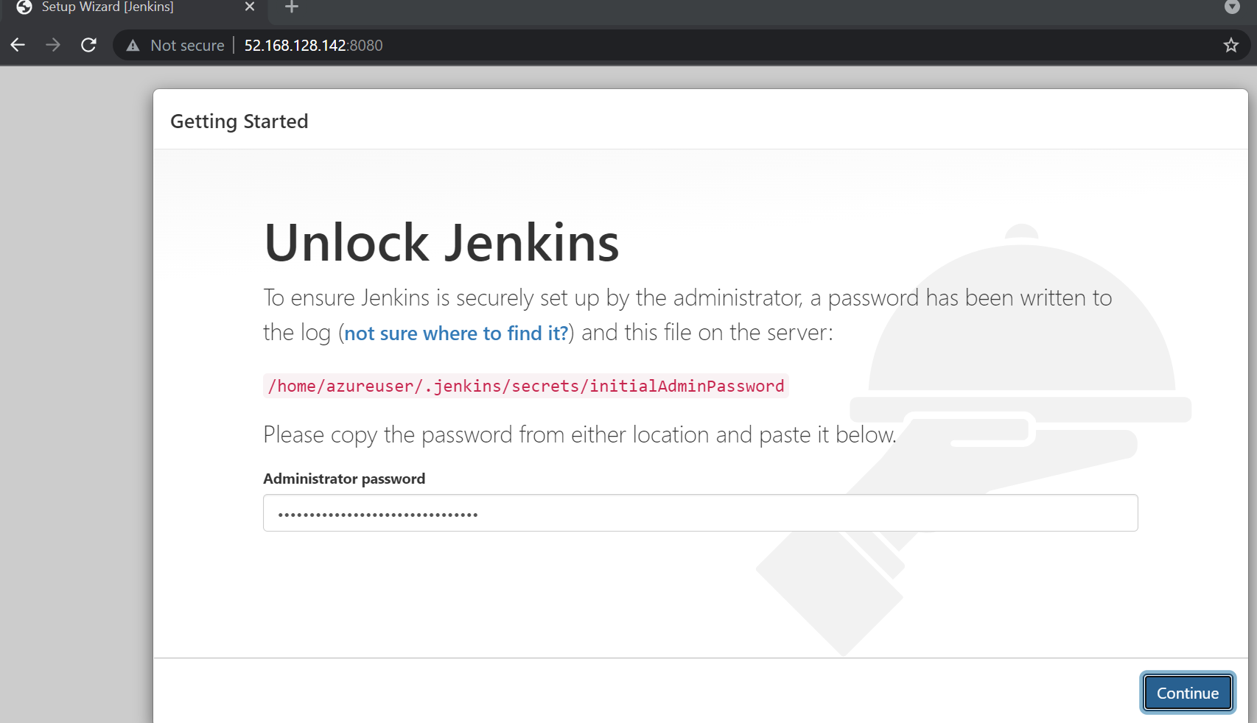

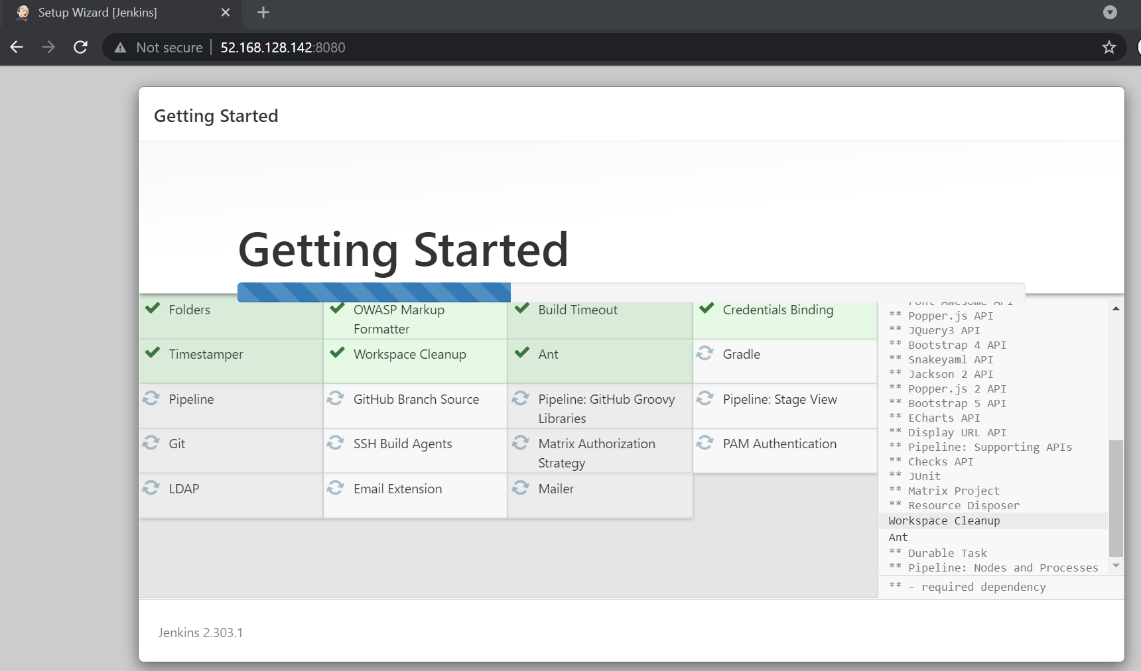

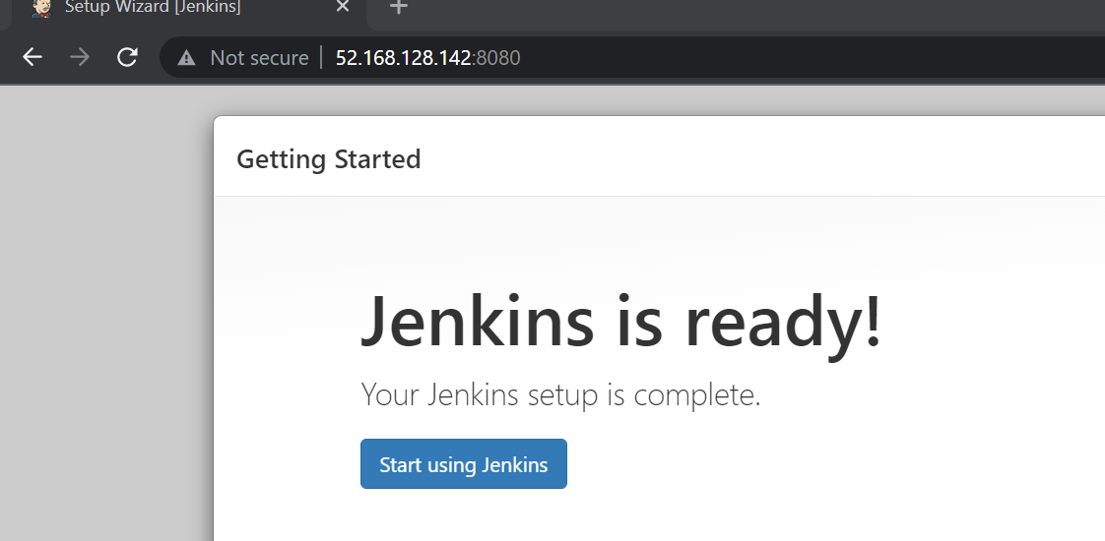

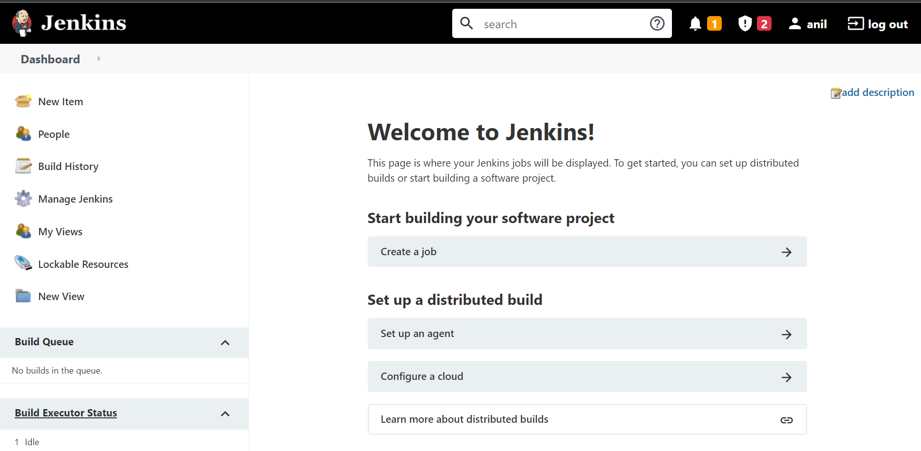

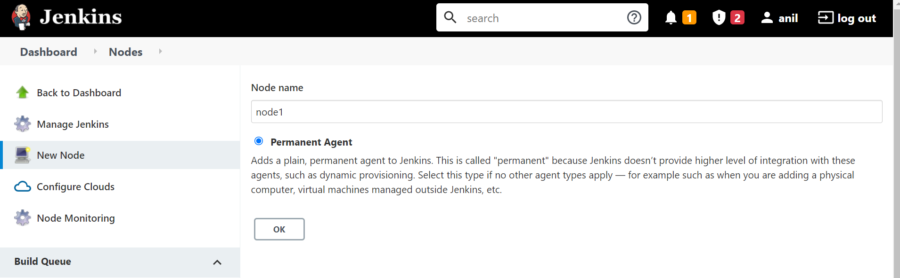

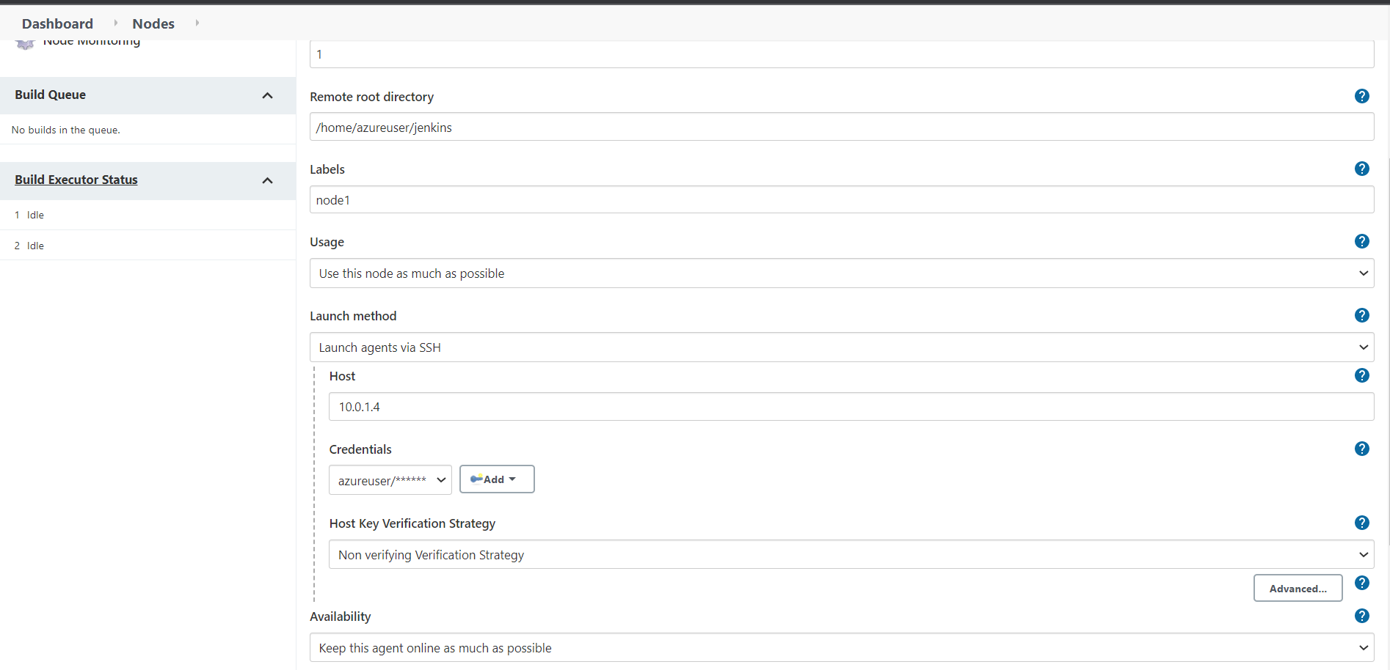

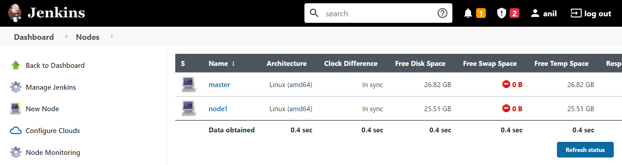

**PART 2**

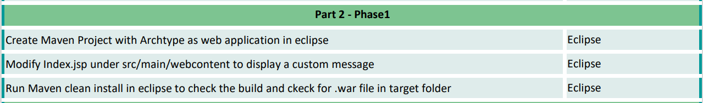

**Create Maven Project with Archtype as web application in eclipse Eclipse**

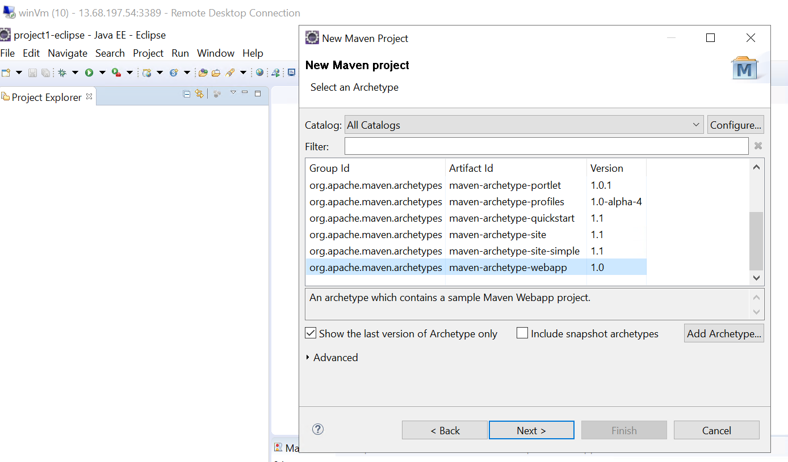

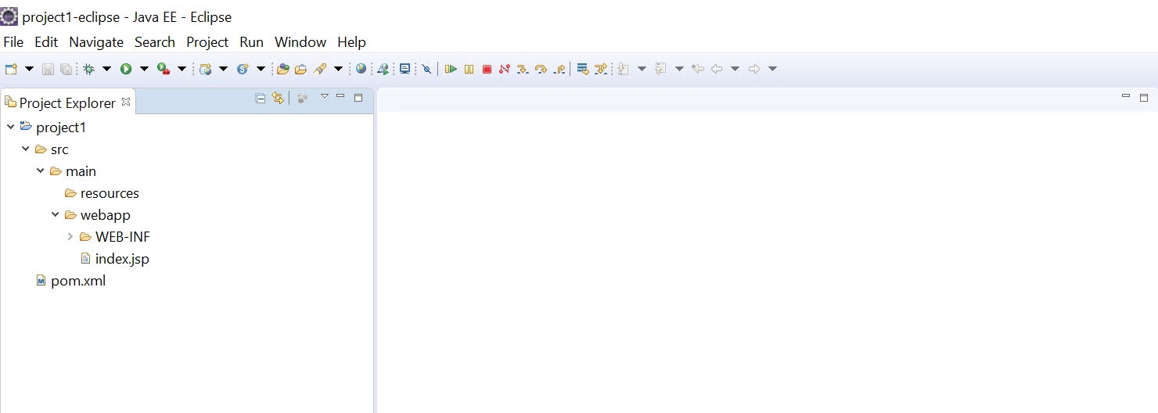

**Modify Index.jsp under src/main/webcontent to display a custom message Eclipse**

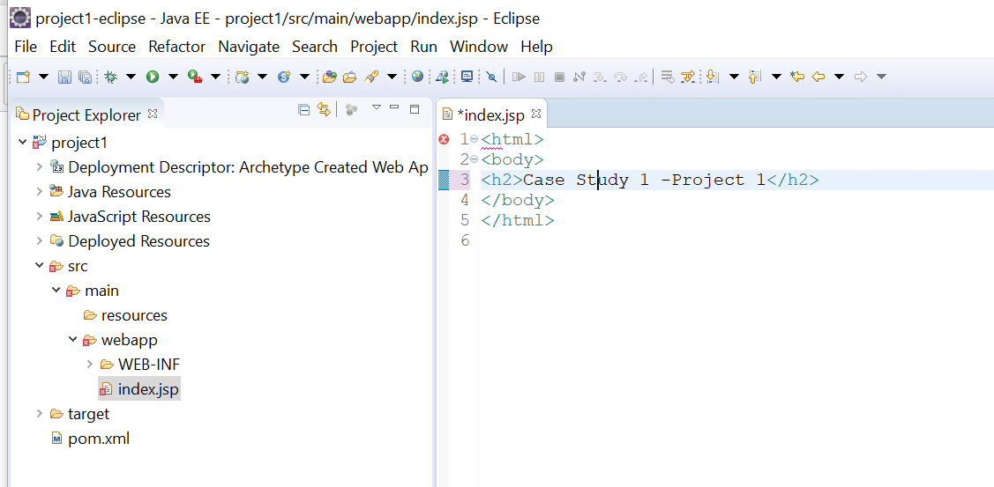

**Run Maven clean install in eclipse to check the build and ckeck for .war file in target folder Eclipse**

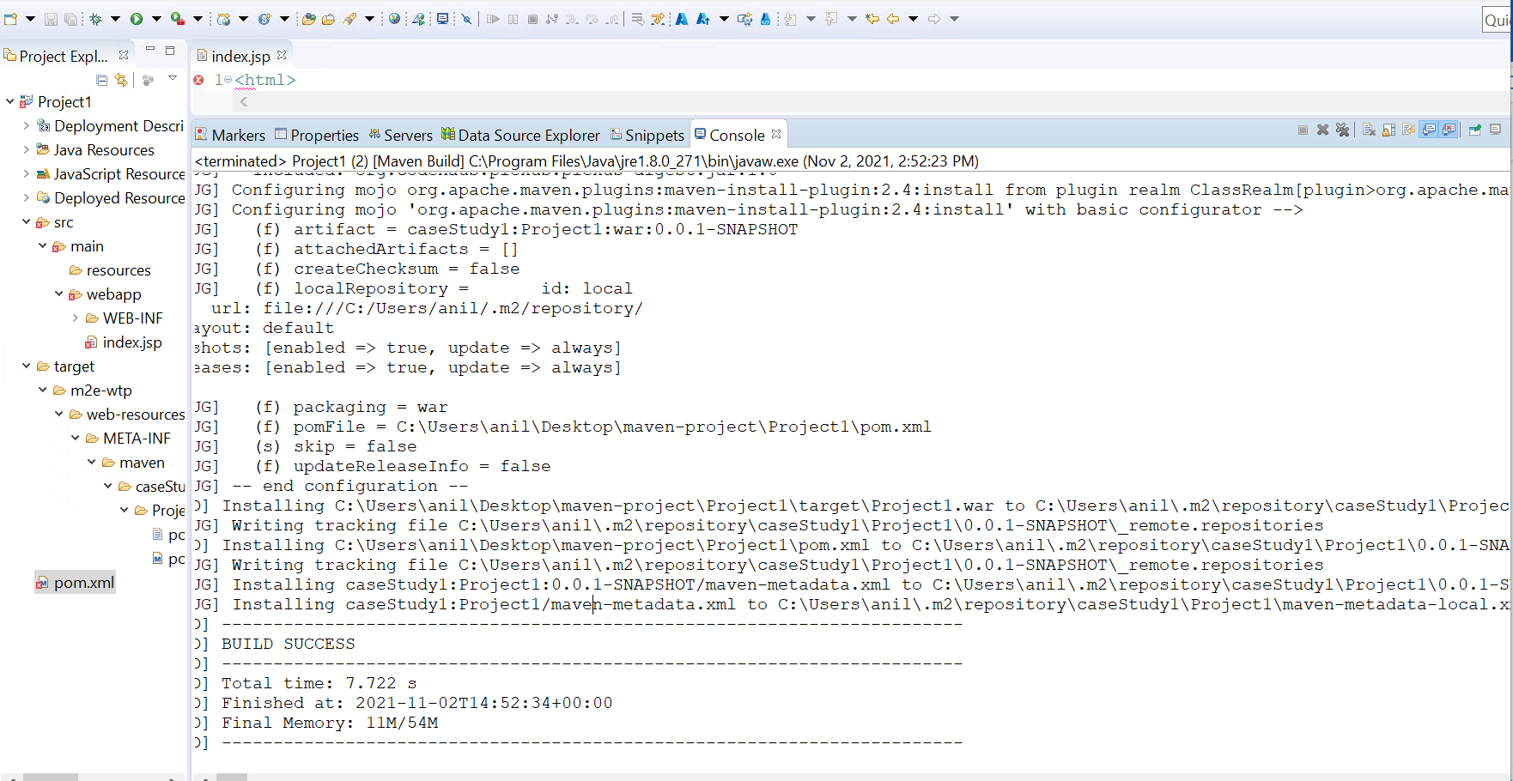

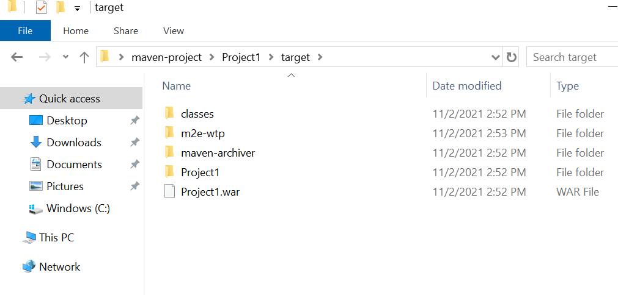

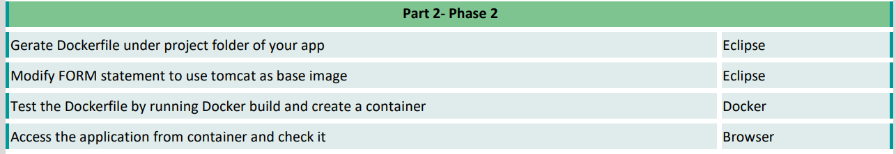

**Genearate Dockerfile under project folder of your app Eclipse**

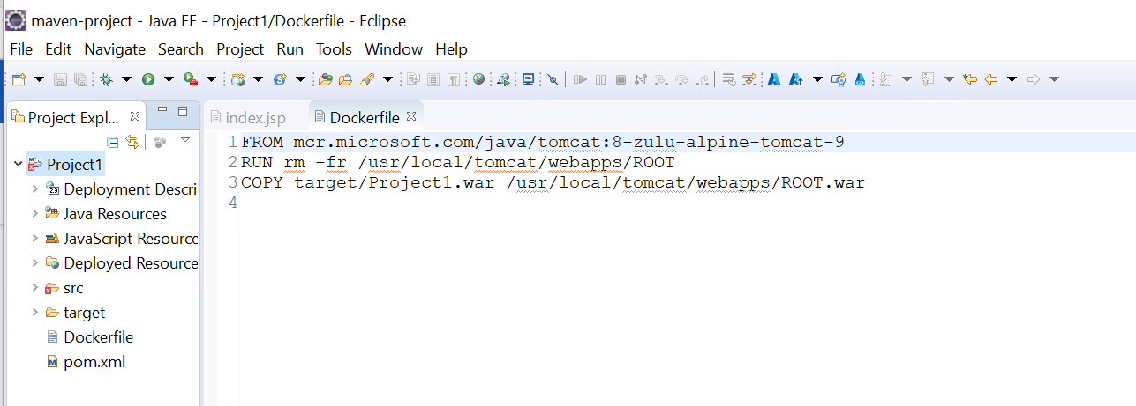

**Modify FORM statement to use tomcat as base image Eclipse**

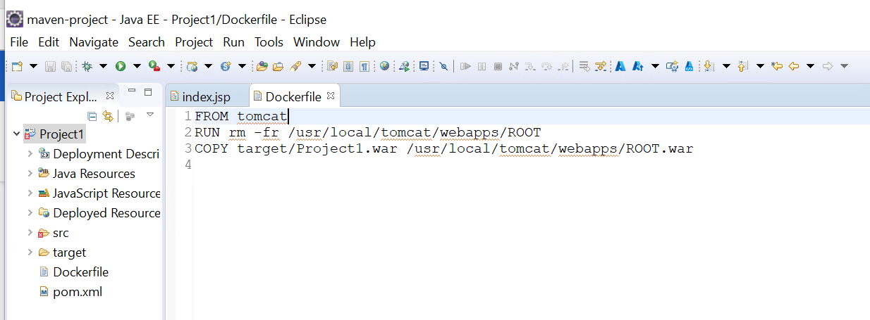

**Test the Dockerfile by running Docker build and create a container Docker**

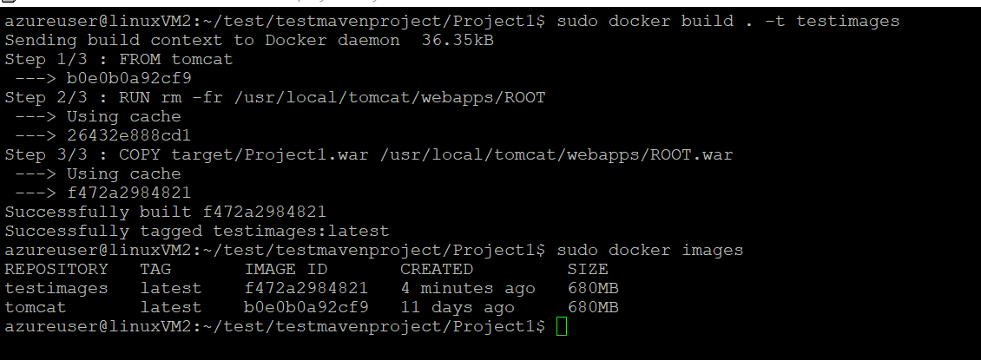

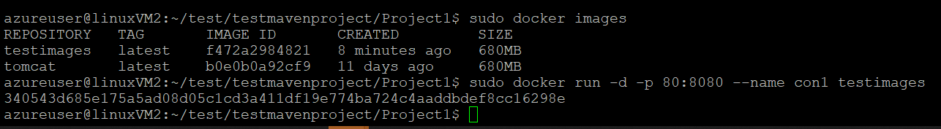

**Access the application from container and check it**

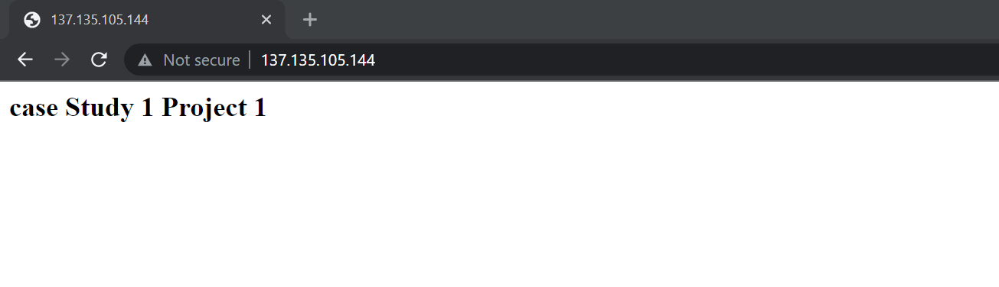

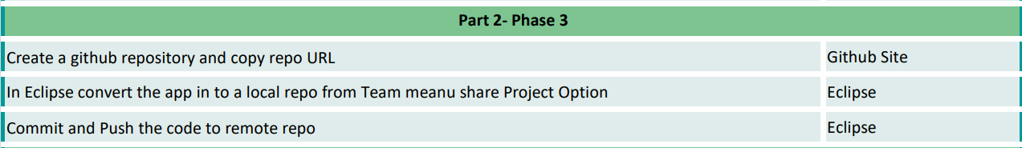

**Create a github repository and copy repo URL Github Site**

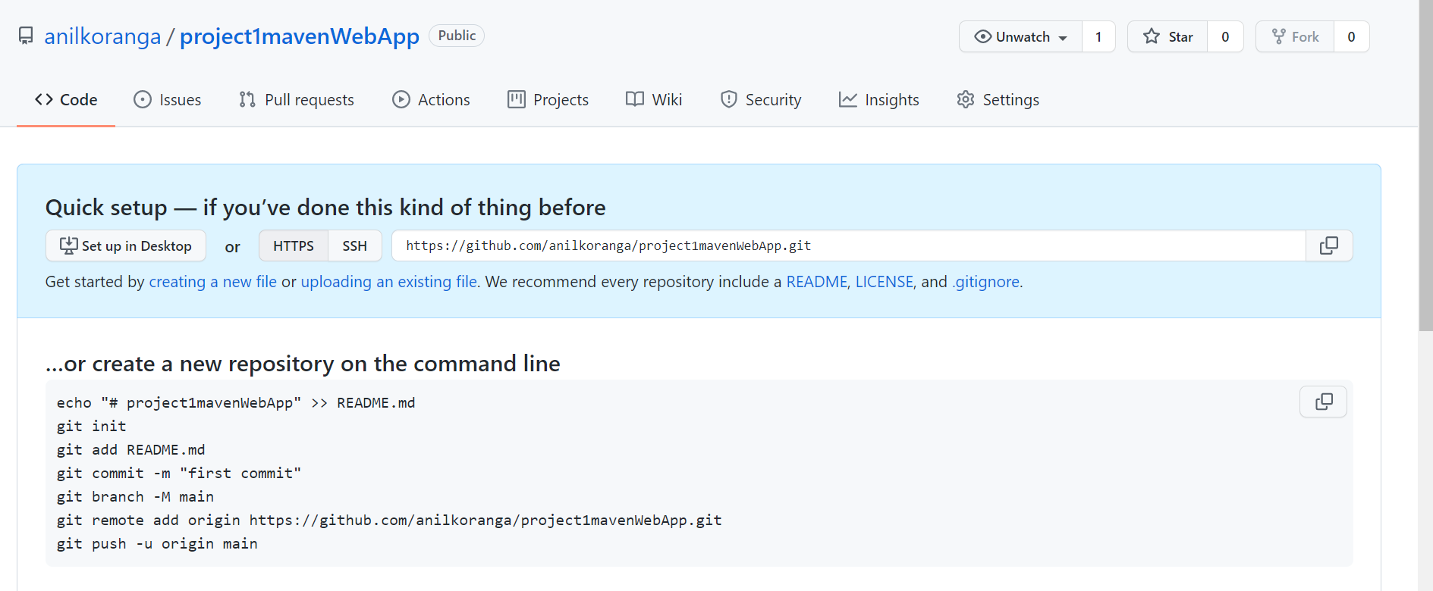

**In Eclipse convert the app in to a local repo from Team meanu share Project Option Eclipse**

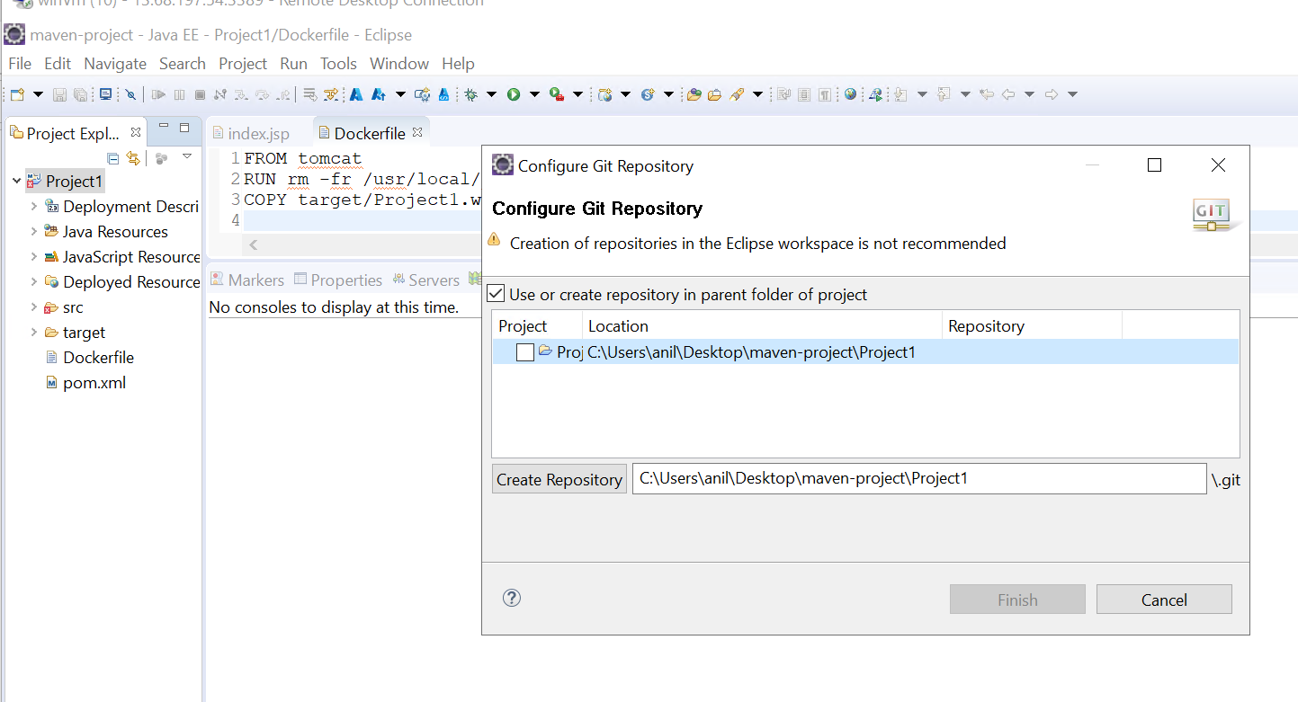

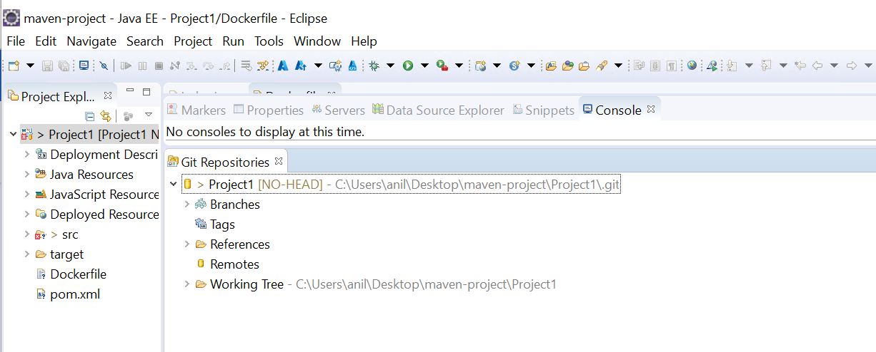

**Commit and Push the code to remote repo**

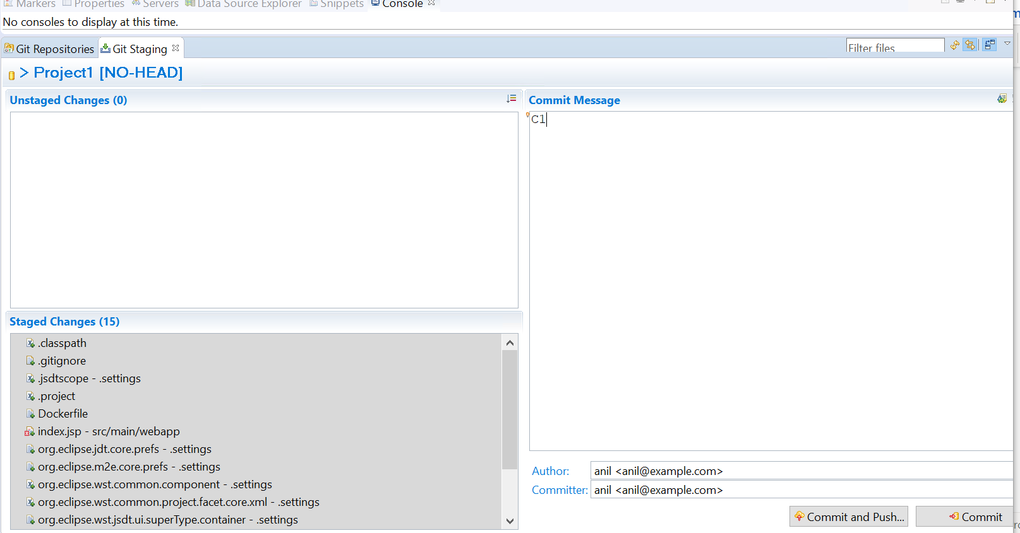

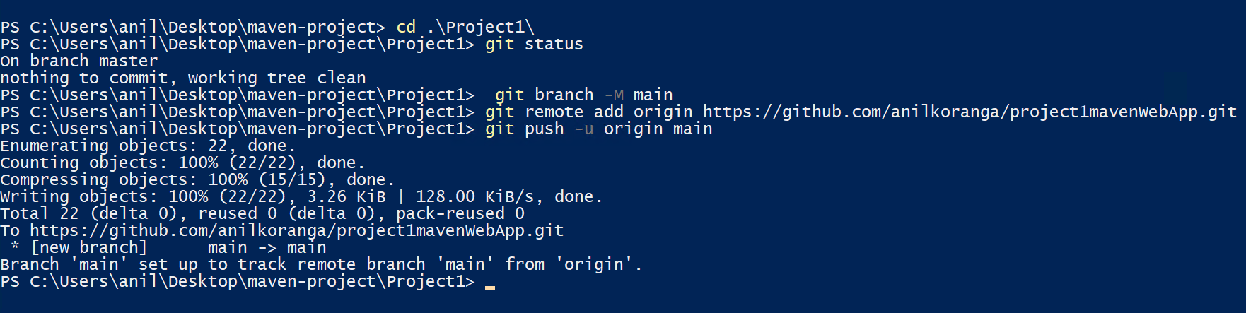

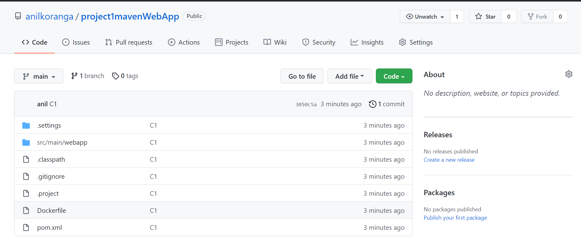

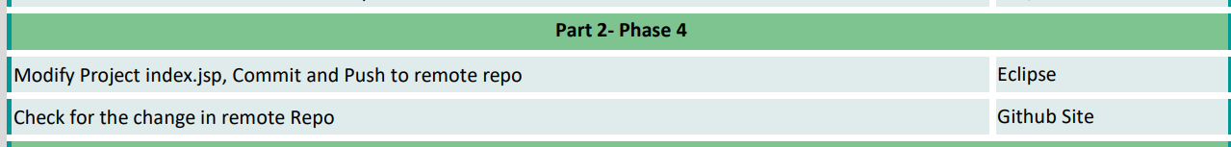

**Modify Project index.jsp, Commit and Push to remote repo**

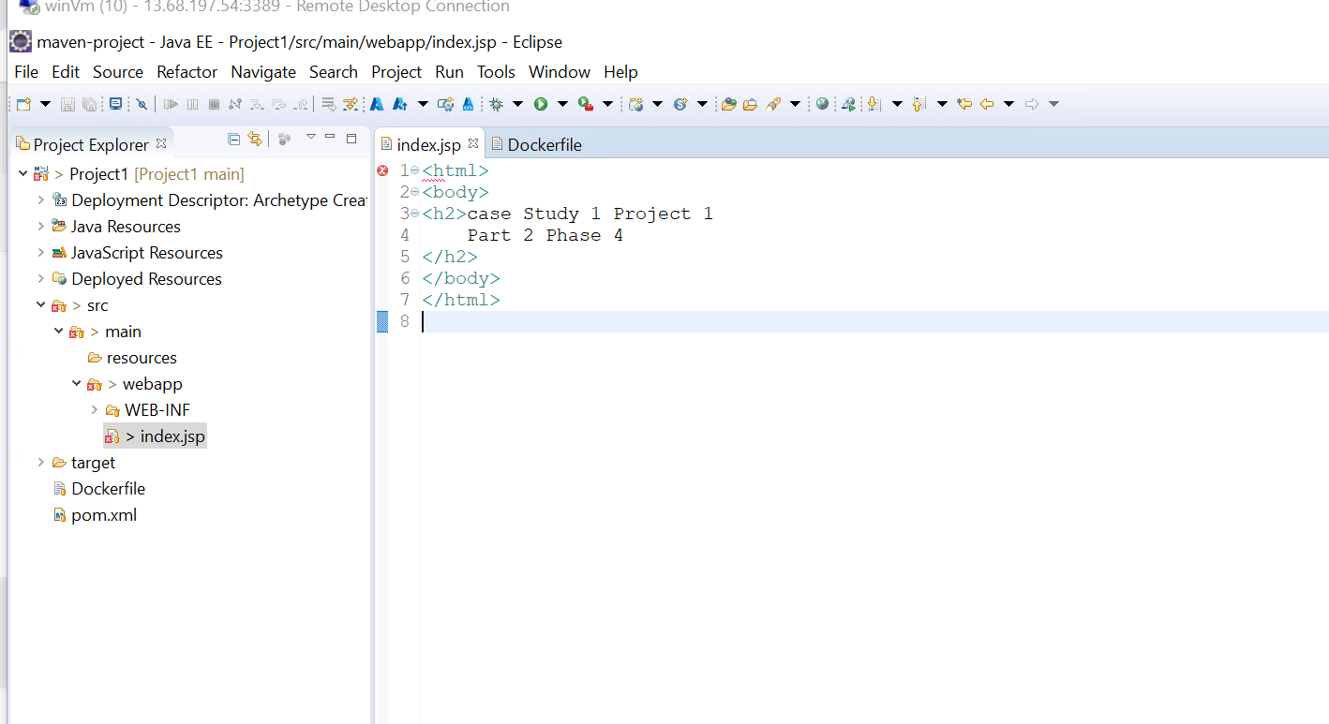

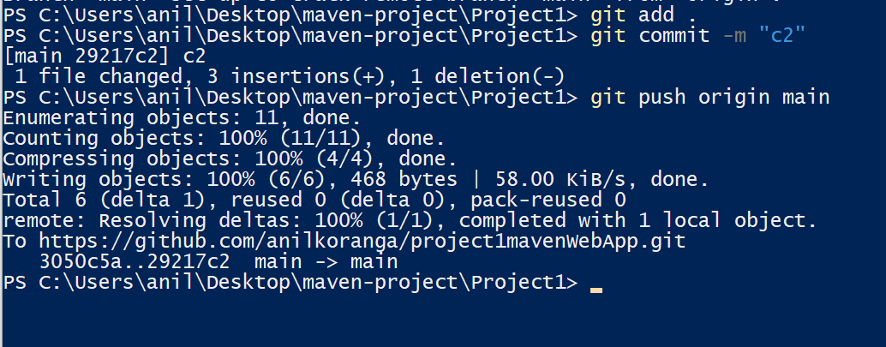

**Check for the change in remote Repo**

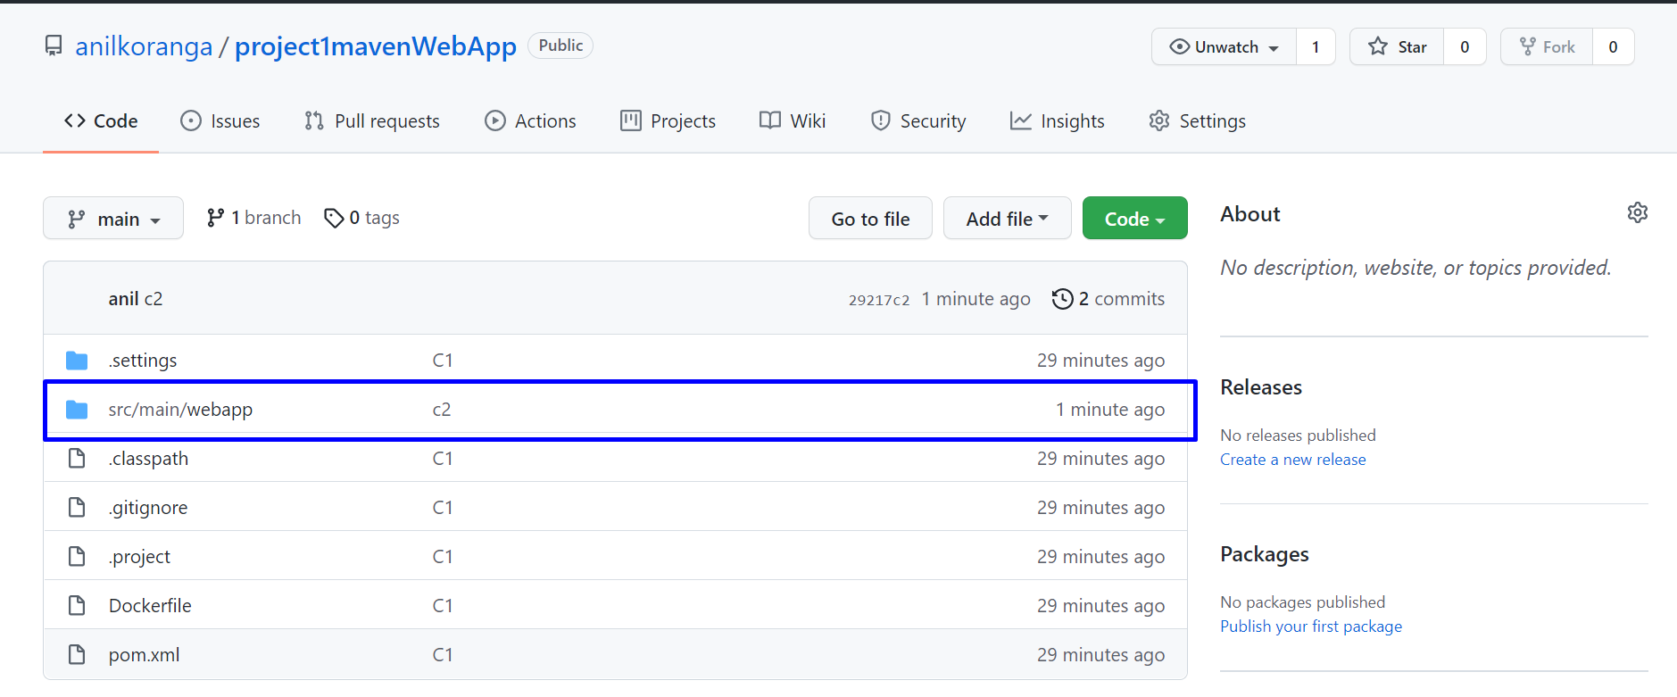

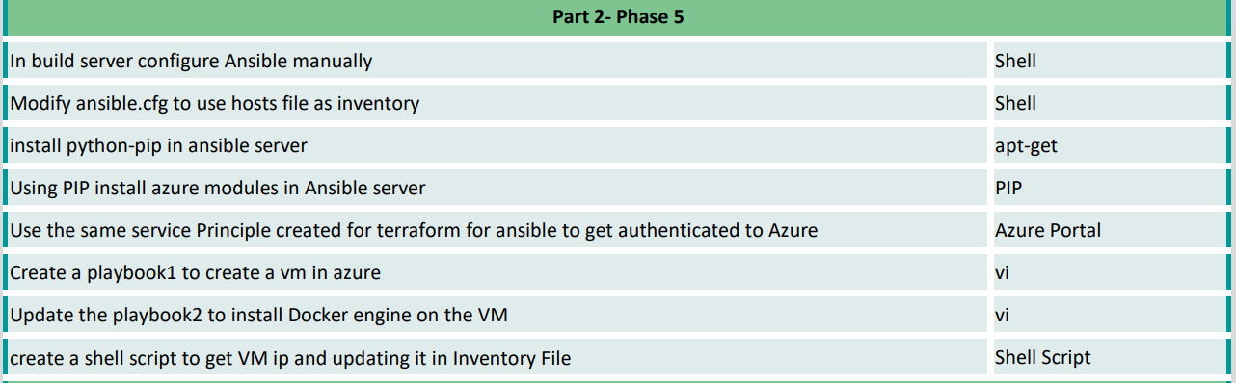

**In build server configure Ansible manually**



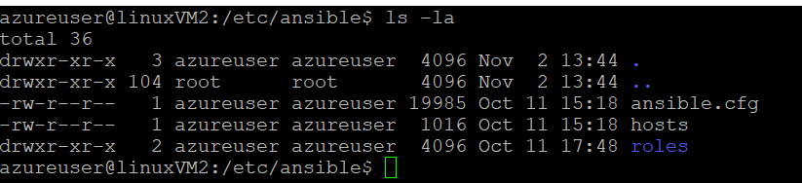

**Modify ansible.cfg to use hosts file as inventory**



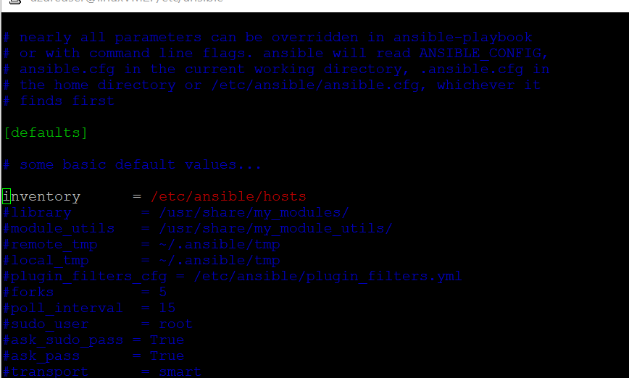

**install python-pip in ansible server**

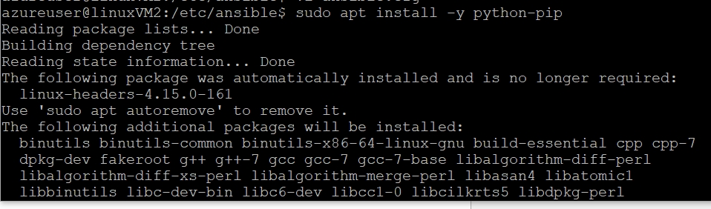

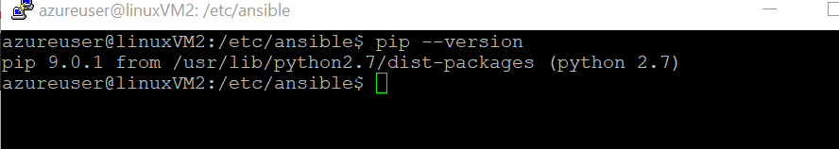

**Using PIP install azure modules in Ansible server**

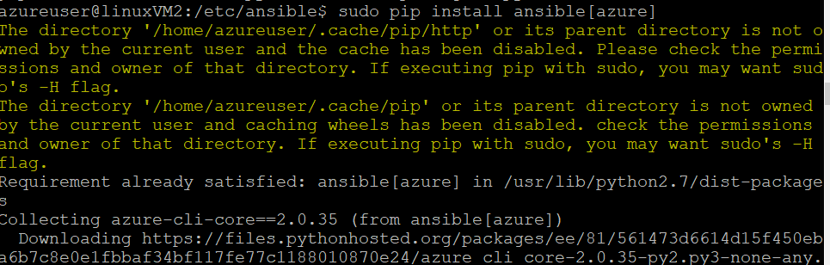

**Use the same service Principle created for terraform for ansible to get authenticated to Azure**

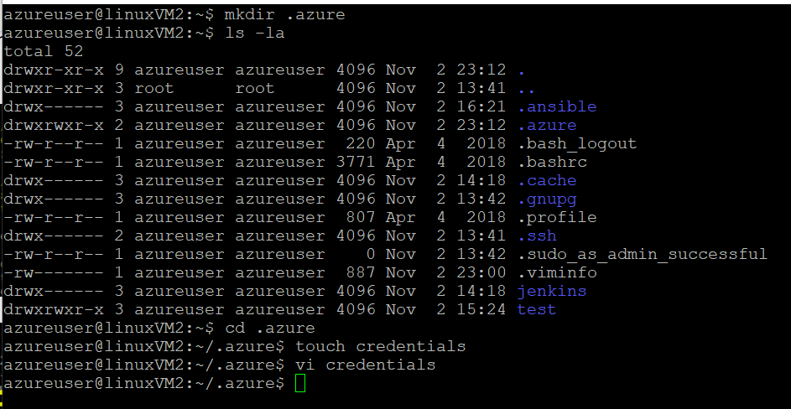

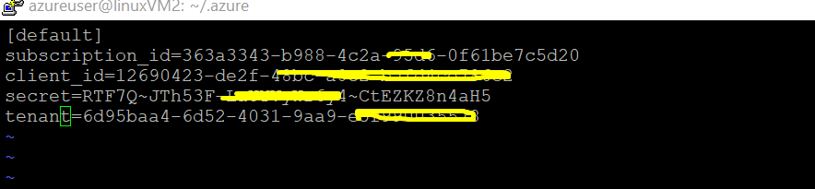

**Create a playbook1 to create a vm in azure**

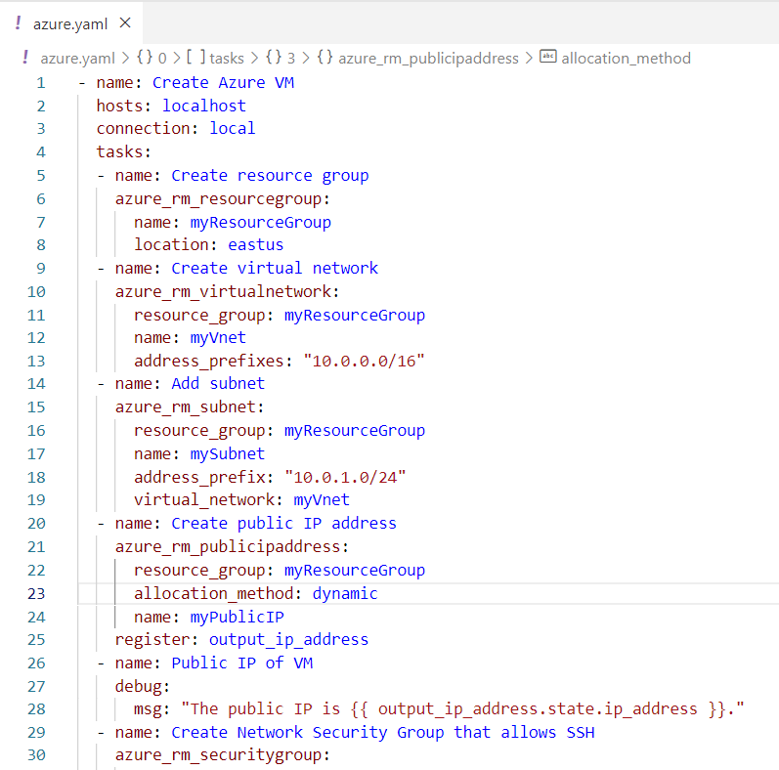

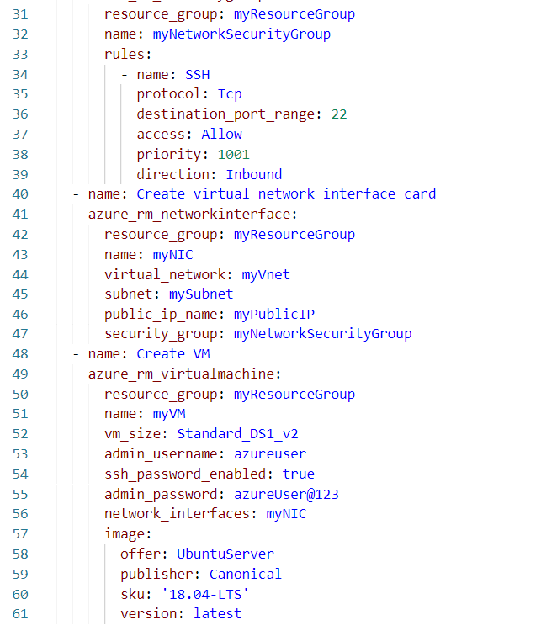

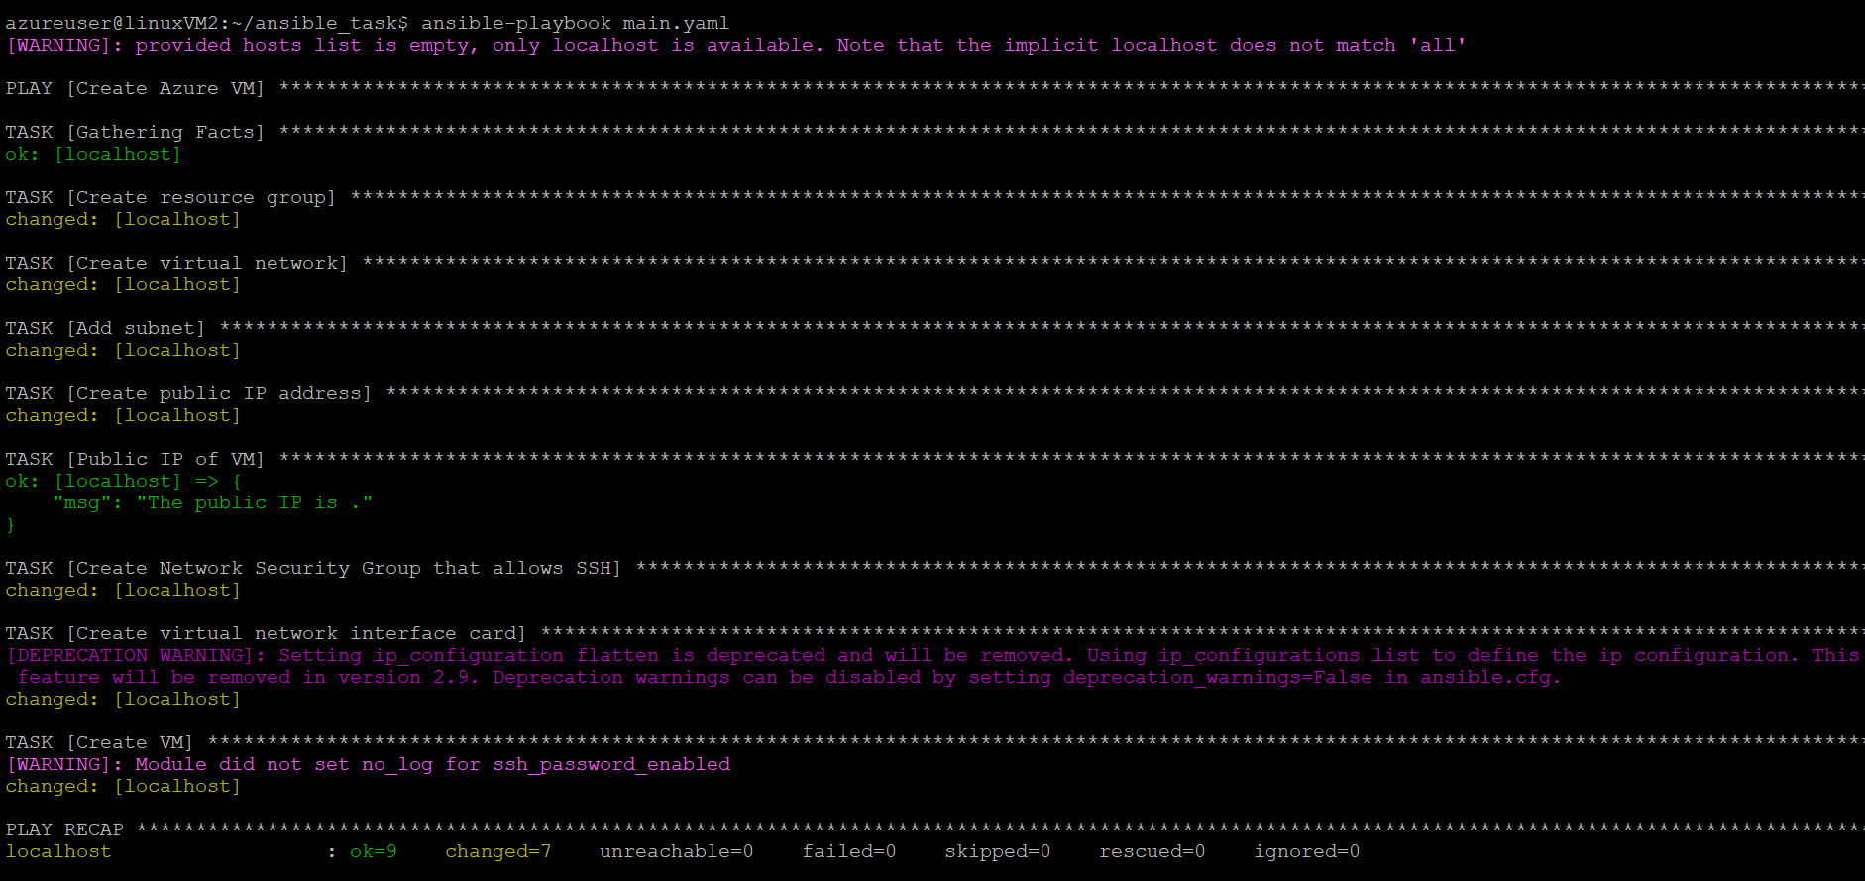



create a shell script to get VM ip and updating it in Inventory File

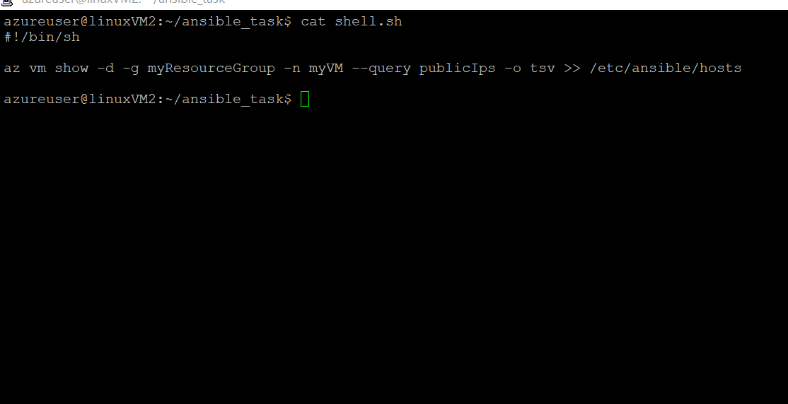

Update the playbook2 to install Docker engine on the VM

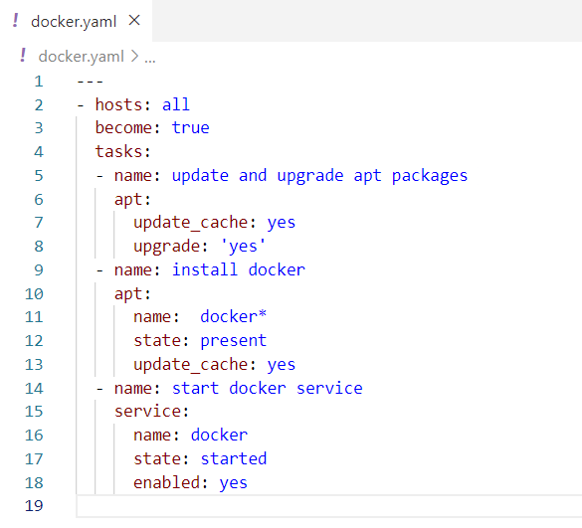

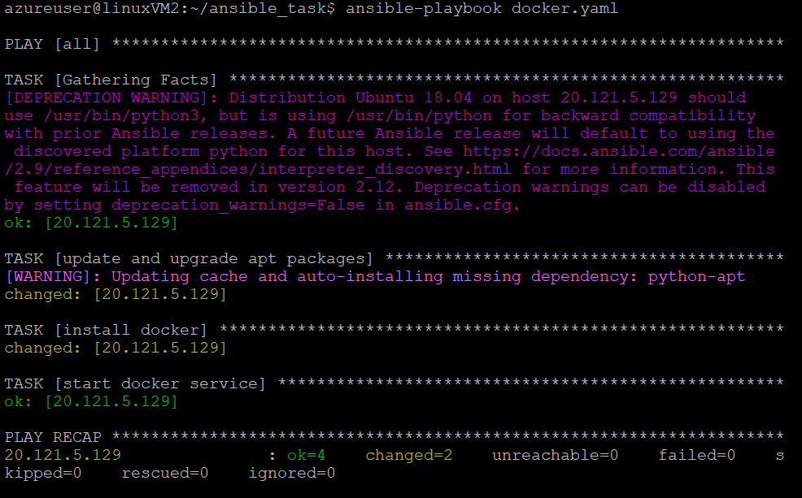

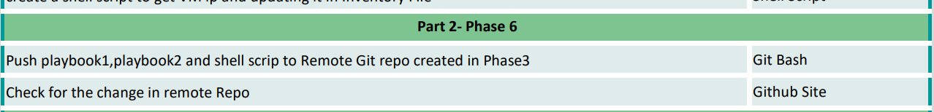

**Push playbook1,playbook2 and shell scrip to Remote Git repo created in Phase3**

**Check for the change in remote Repo**

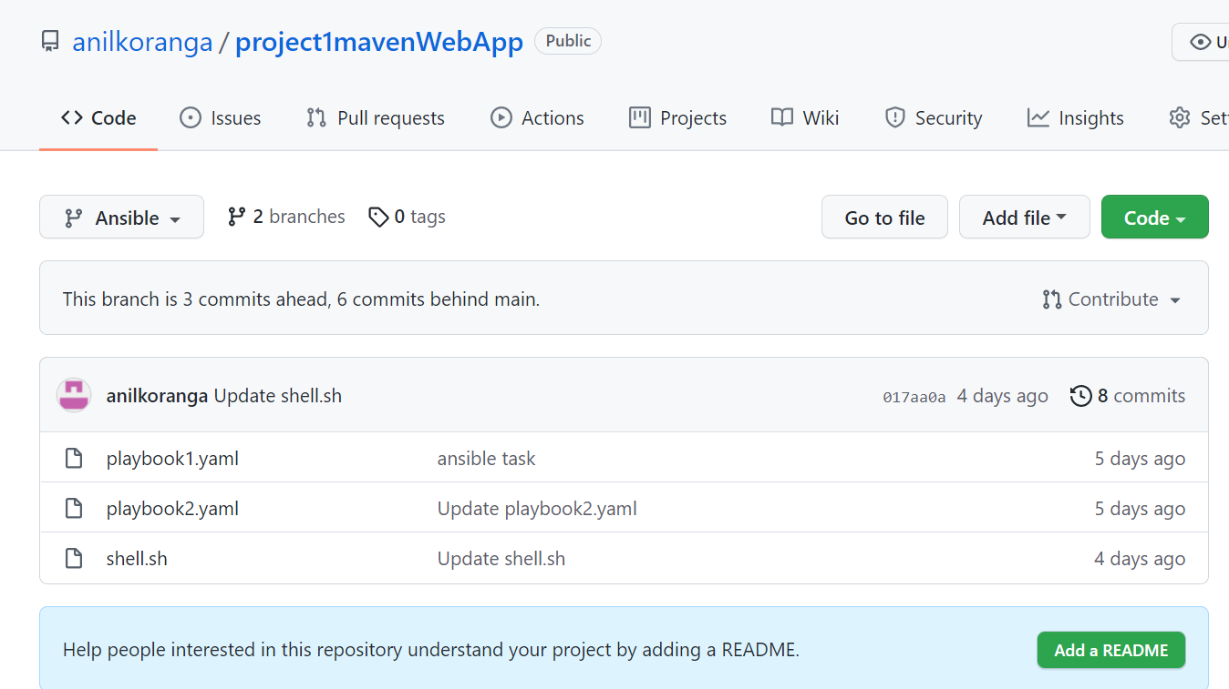



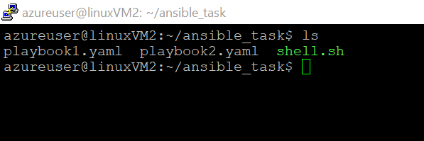

Playbook 1 execution

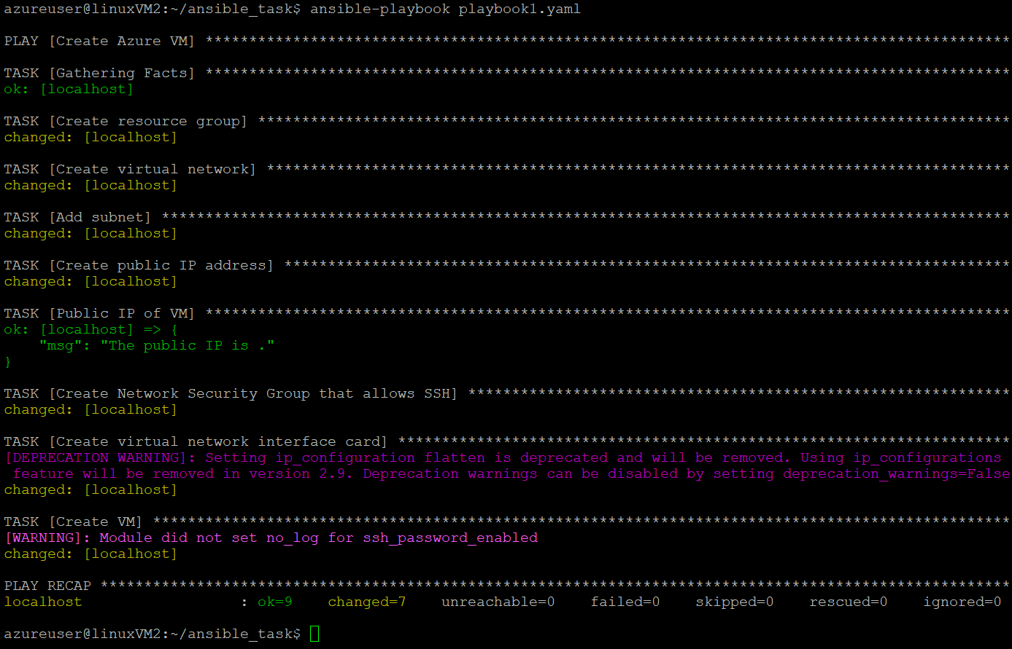

Shell script execution

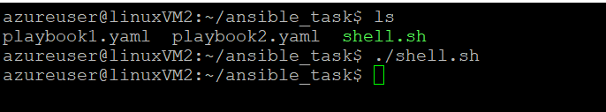

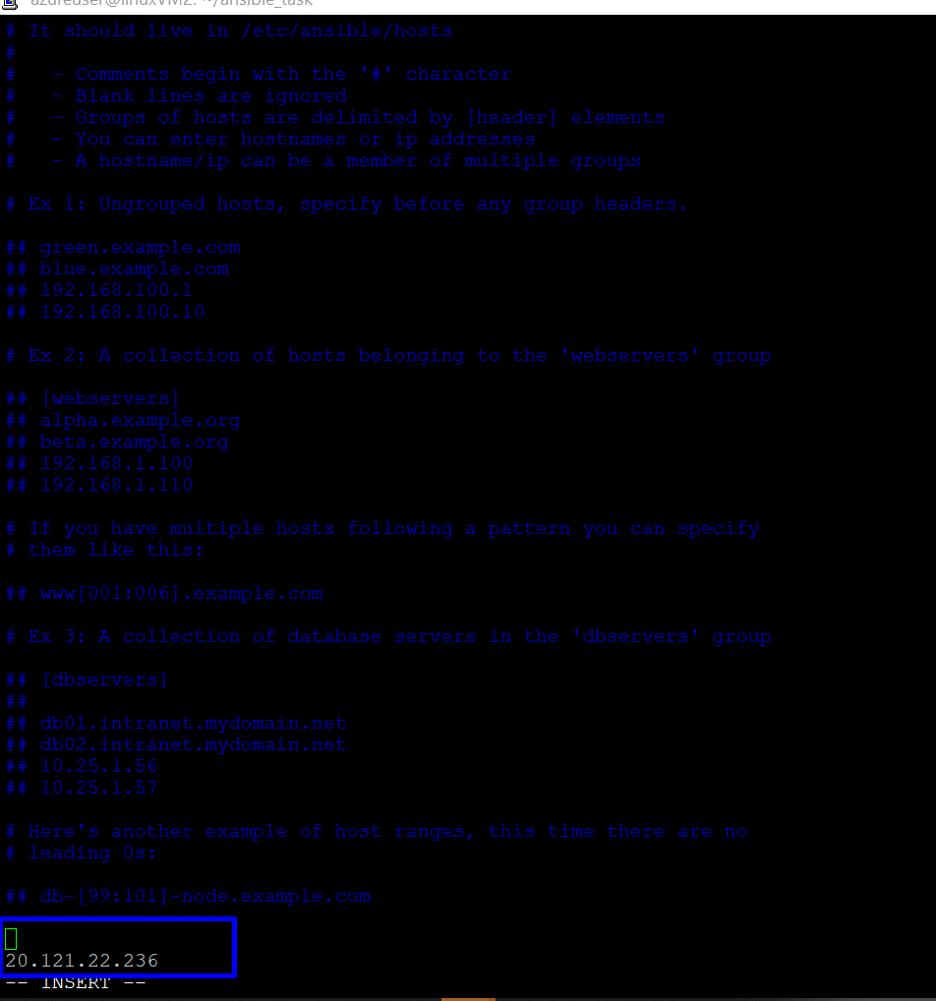

Playbook 2

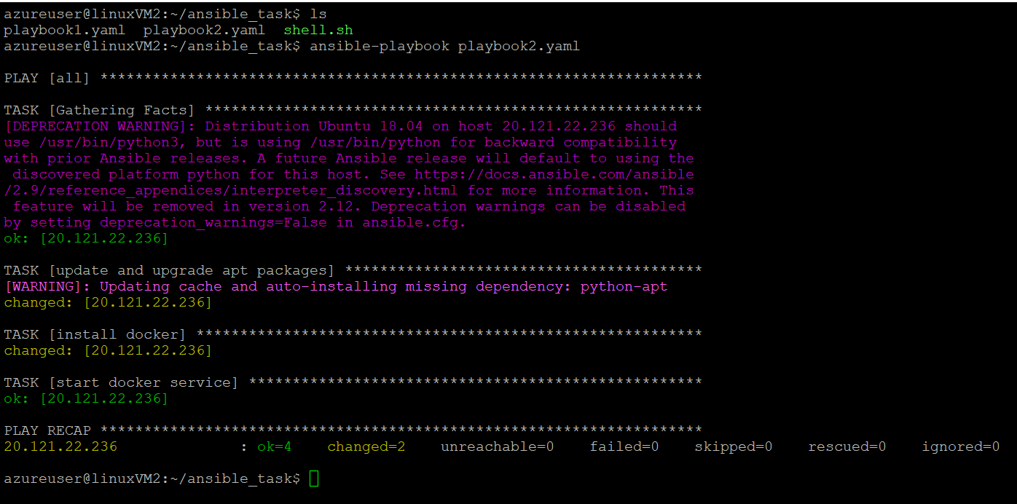

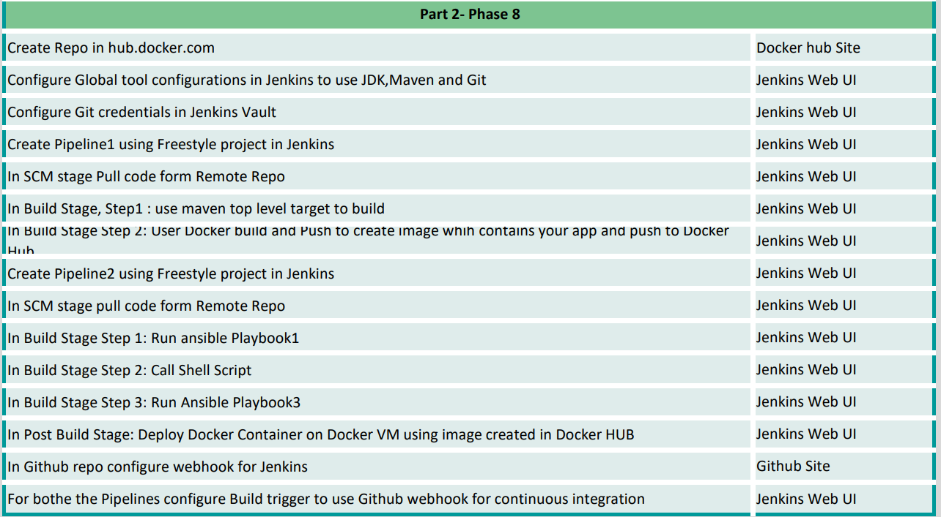

**Create Repo in hub.docker.com**

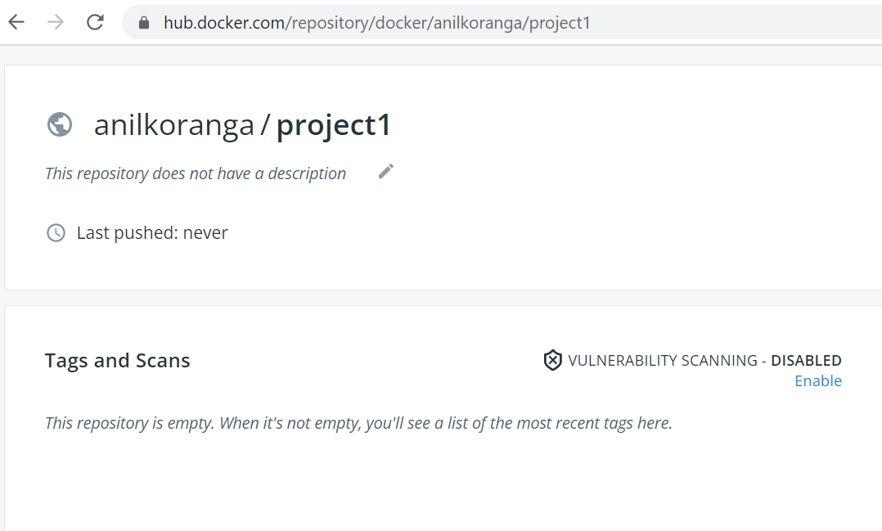

**Configure Global tool configurations in Jenkins to use JDK,Maven and Git**

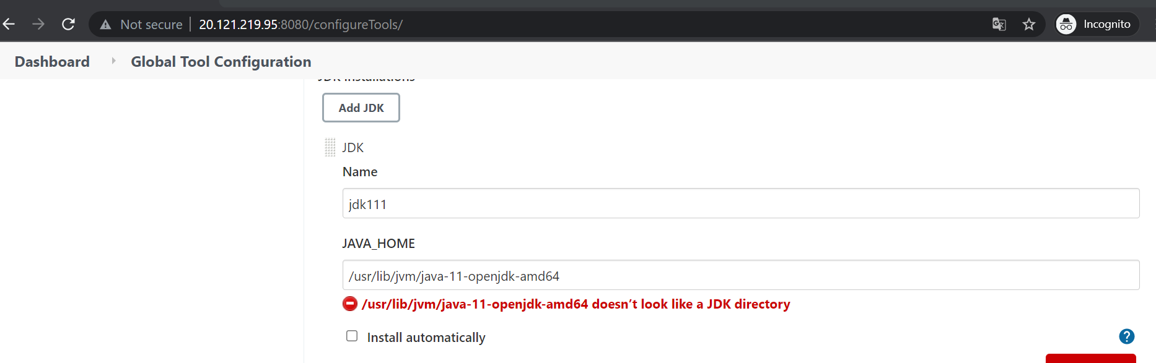

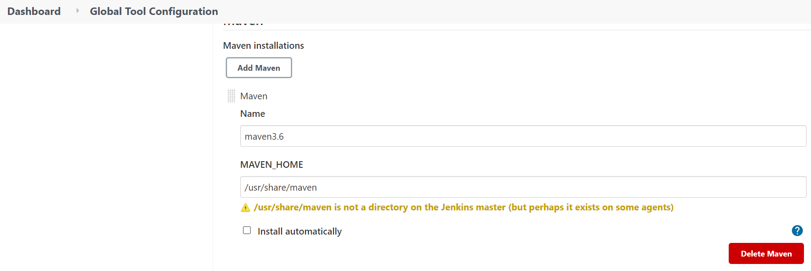

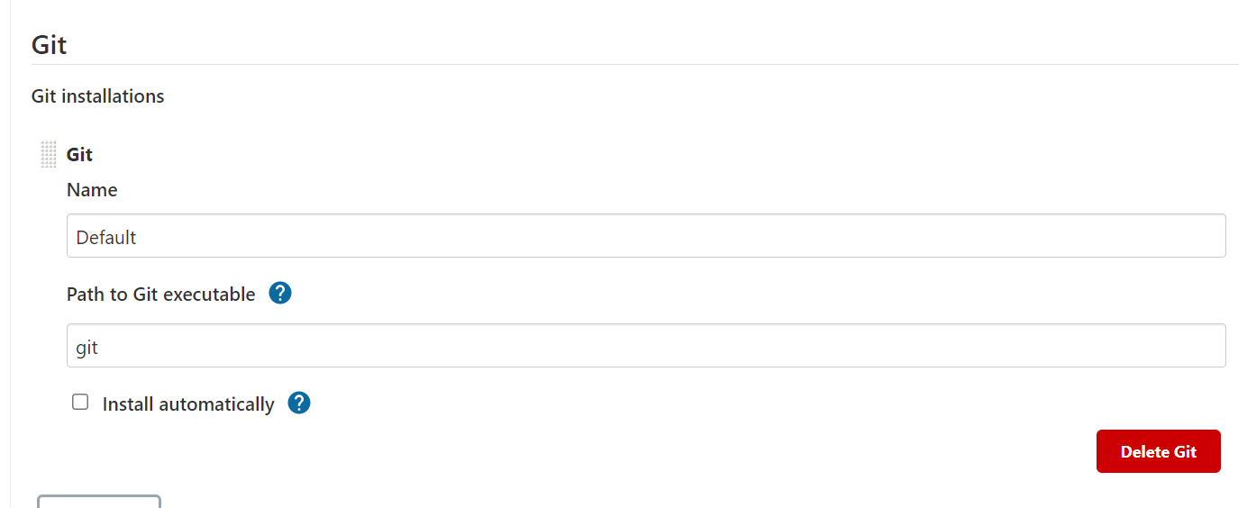

**Configure Git credentials in Jenkins Vault**

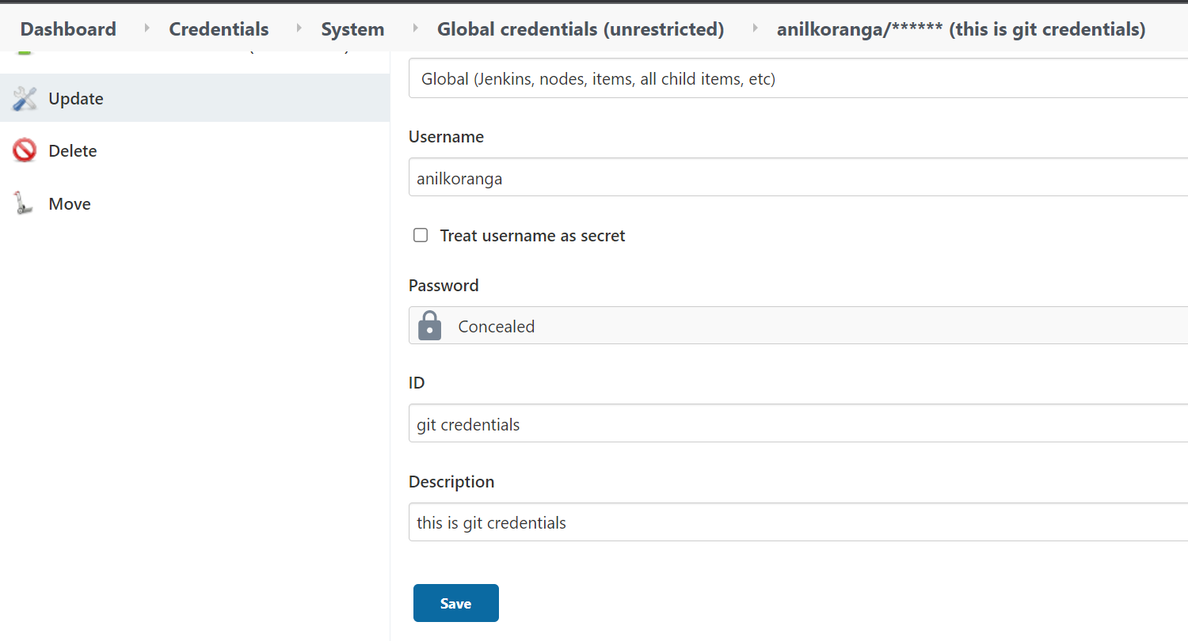

**Create Pipeline1 using Freestyle project in Jenkins**

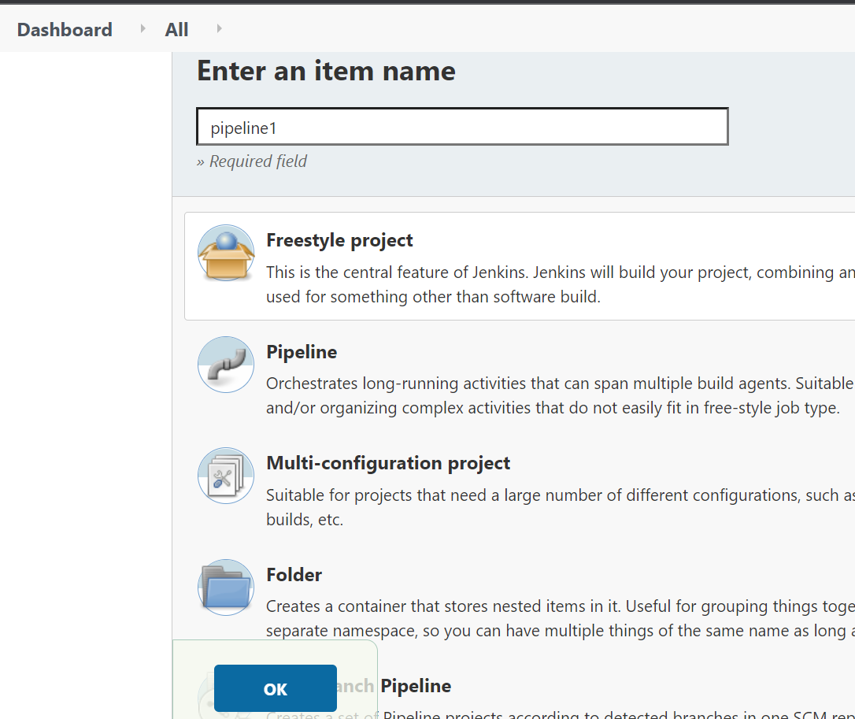

**In SCM stage Pull code form Remote Repo**

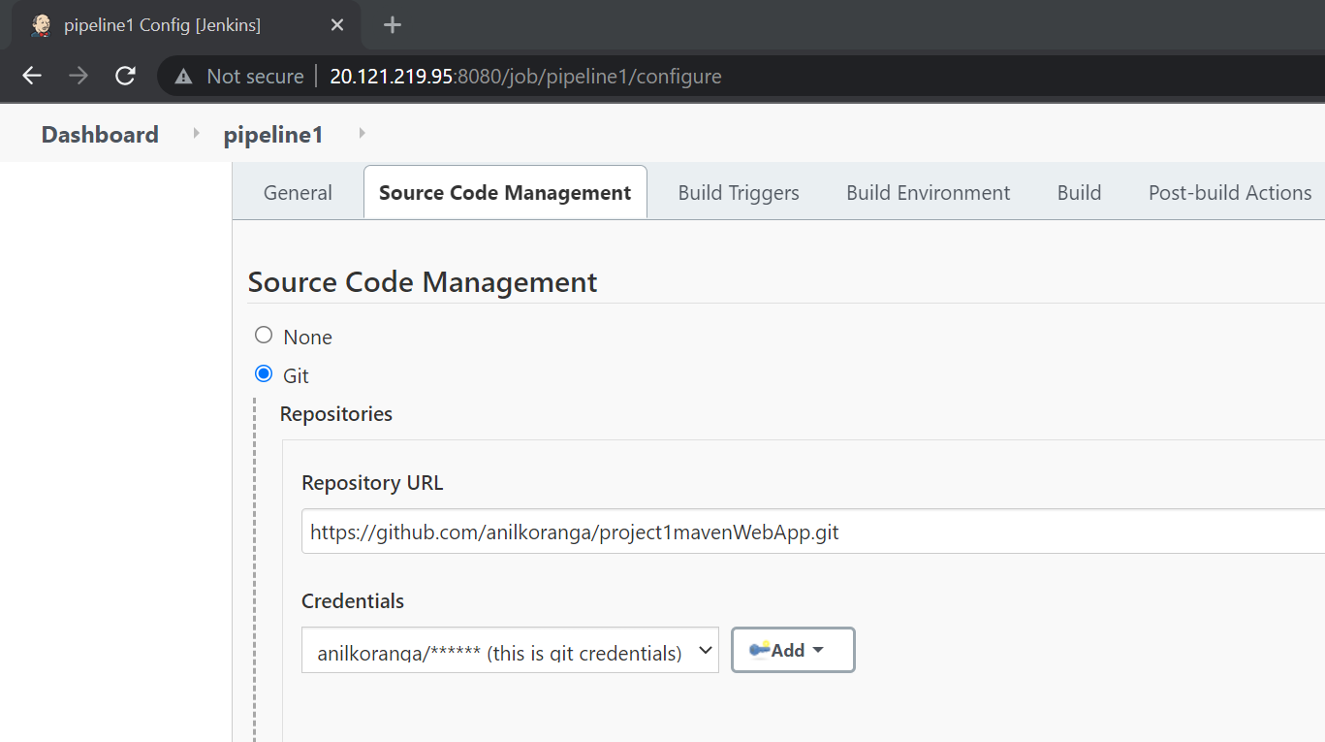

**In Build Stage, Step1 : use maven top level target to build**

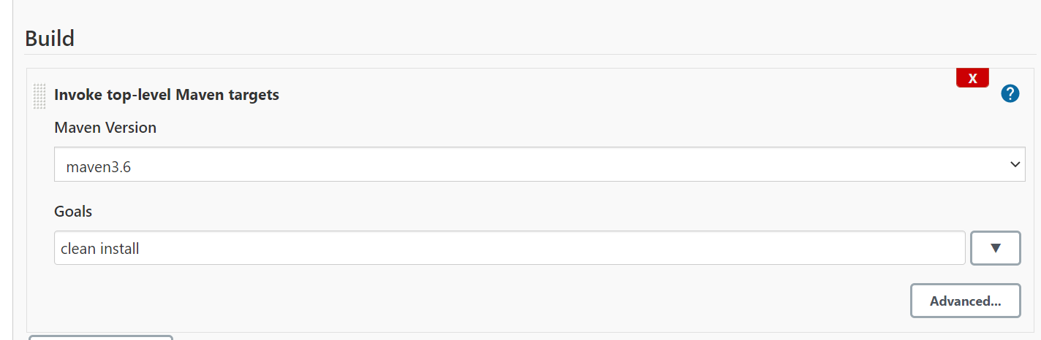

**In Build Stage Step 2: User Docker build and Push to create image whih contains your app and push to Docker Hub**

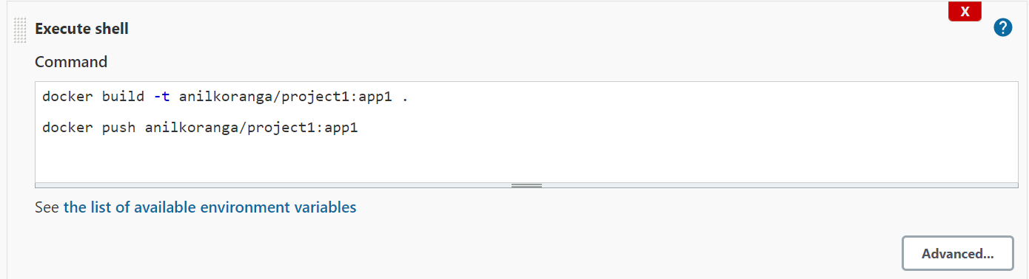

**Create Pipeline2 using Freestyle project in Jenkins**

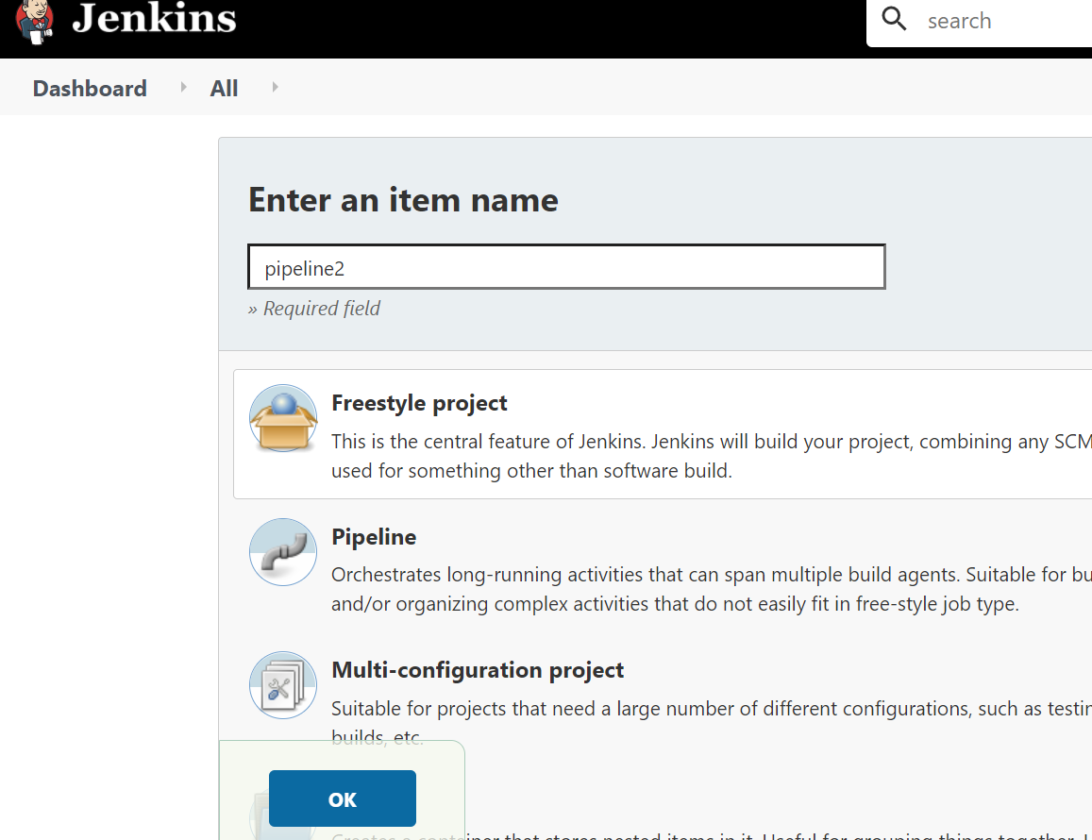‘

**In SCM stage pull code form Remote Repo**

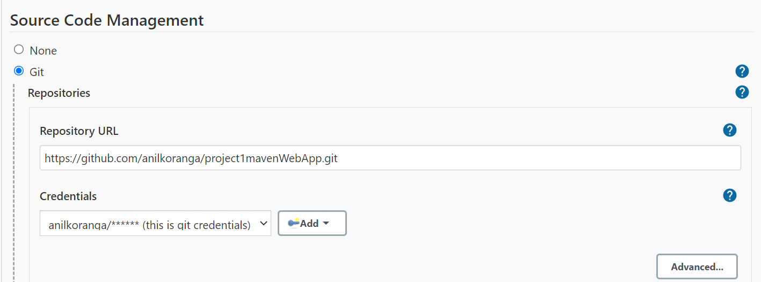

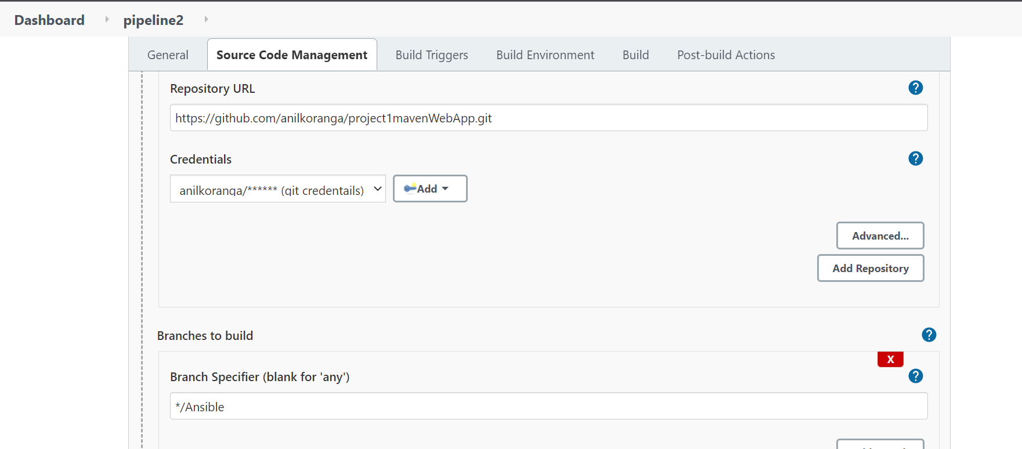

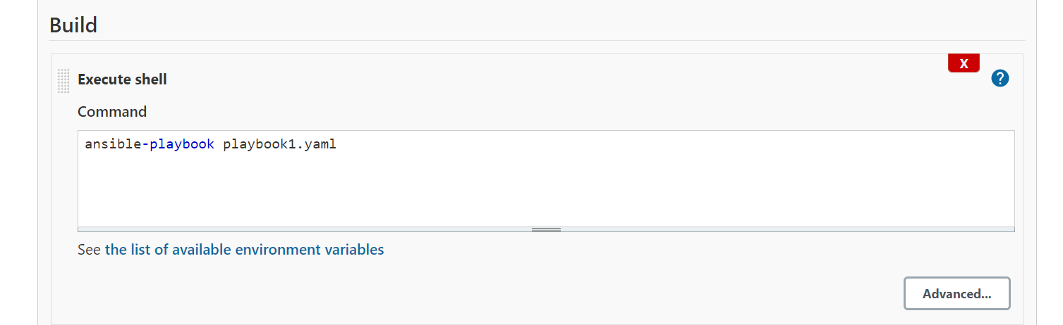

**In Build Stage Step 1: Run ansible Playbook1**

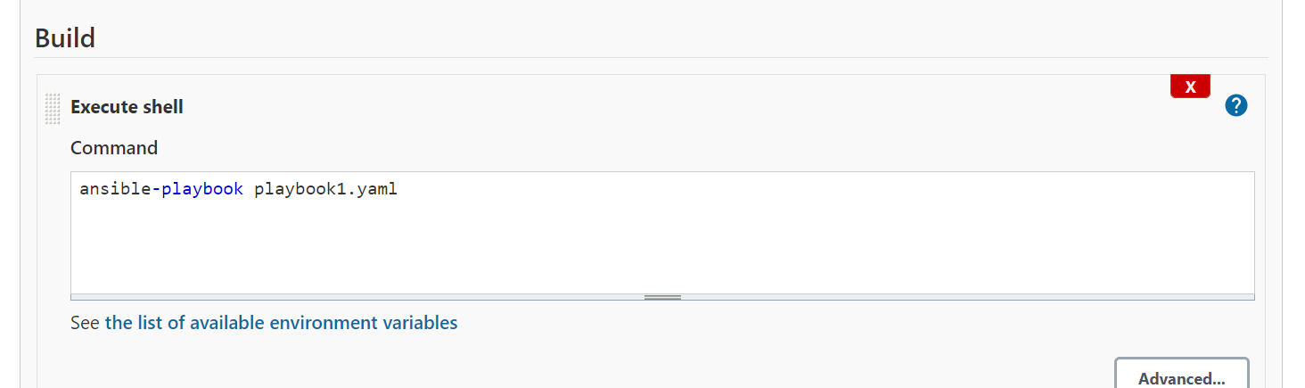

**In Build Stage Step 2: Call Shell Script**

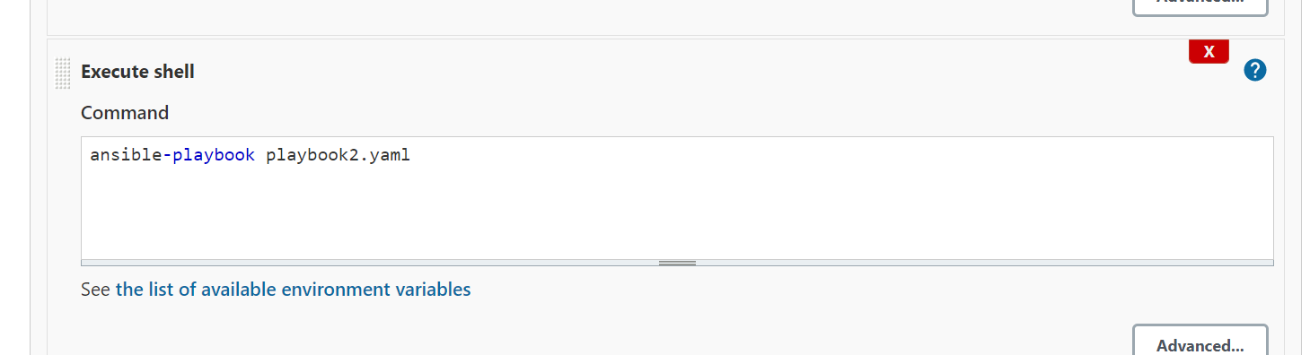

**In Post Build Stage: Deploy Docker Container on Docker VM using image created in Docker HUB**

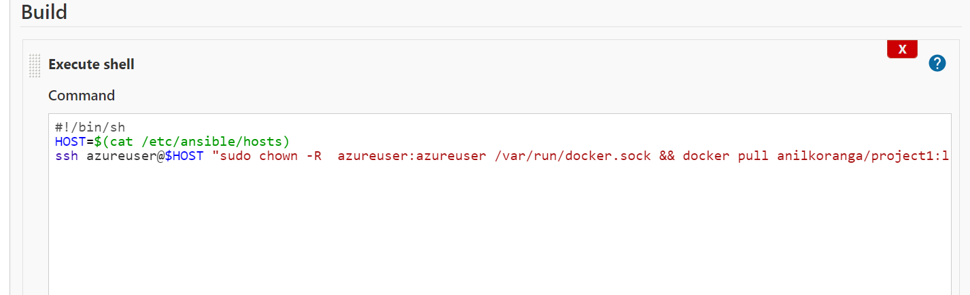

**In Github repo configure webhook for Jenkins**

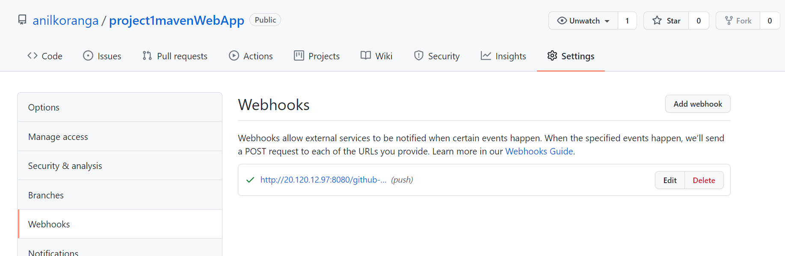

**For both the Pipelines configure Build trigger to use Github webhook for continuous integration**

Pipeline 1

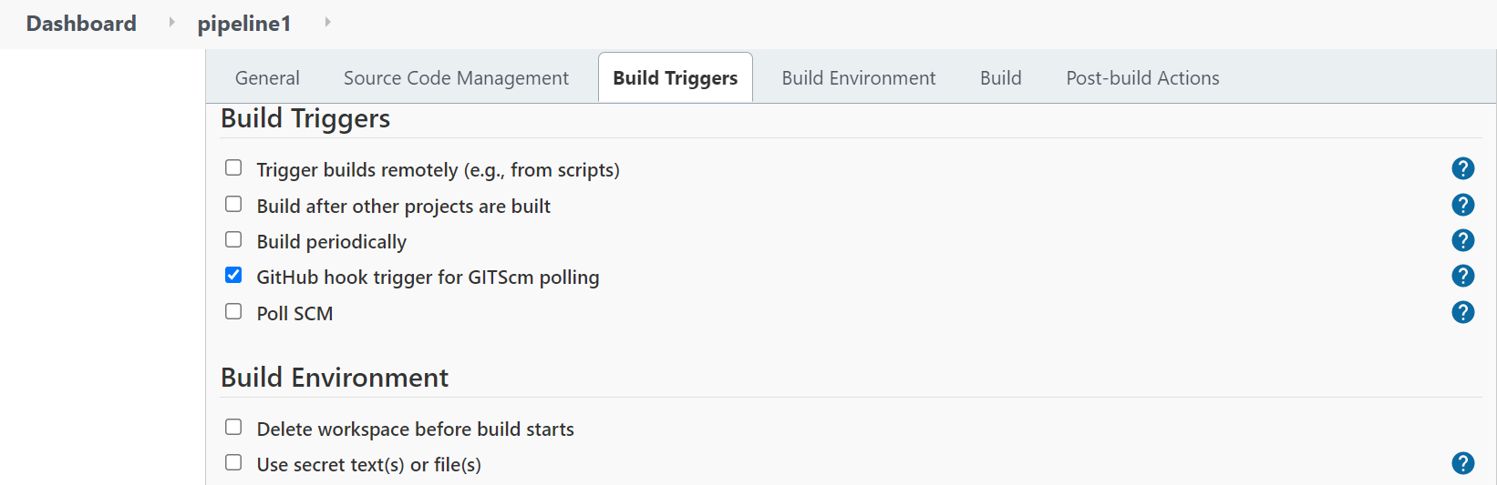

Pipeline 2

